EMF Management handbook
Working Draft – June 2015

DISCLAIMER
This document refers to various standards, guidelines, calculations, legal requirements, technical details and other information.
Over time, changes in Australian Standards, industry standards and legislative requirements, as well as technological advances and other factors relevant to the information contained in this document, may affect the accuracy of the information contained in this document. Accordingly, caution should be exercised in relation to the use of the information in this document.
The Energy Networks Association Limited (ENA) accepts no responsibility for the accuracy of any information contained in this document or the consequences of any person relying on such information.
Correspondence should be addressed to the CEO, Energy Networks Association, Level 1, 110 Giles Street, Kingston ACT 2604
COPYRIGHT ©
Energy Networks Association 2015
All rights are reserved. No part of this work may be reproduced or copied in any form or by any means, electronic or mechanical, including photocopying, without the written permission of the Association.
Published by Standards Australia International Ltd, GPO Box 5420, Sydney, NSW 2001 for the Energy Networks Association, Level 1, 110 Giles Street, Kingston ACT 2604.
ISBN:

CONTENTS

1. INTRODUCTION 1
2. SCOPE 2
3. ELECTRIC AND MAGNETIC FIELDS 3
3.1. Electric fields 3
3.2. Magnetic fields 4
3.3. Typical field levels in the environment 5
3.4. Magnetic field sources around the home 6
3.5. High field occupational environments 7
4. THE SCIENCE OF EMF AND HEALTH 9
4.1. Conclusions FROM public health authorities 9
5. EMF GUIDELINES AND EXPOSURE LIMITS 11
5.1. Summary of Basic Restrictions 12
5.2. Summary of Reference Levels 13
6. METHODS FOR ASSESSING COMPLIANCE WITH EXPOSURE LIMITS 14
6.1. Magnetic field sources – minimum compliance distances 16
6.2. Electric field sources - considerations 17
6.3. Calculations or measurements of external fields 17
6.4. Adjustments for highly localised non-uniform fields 18
6.5. Modelling internal electric field 20
7. PRUDENT AVOIDANCE / PRECAUTION 23
7.1. ENA position 23
7.2. Precaution – World Health Organization 23
7.3. Summary of prudent avoidance / precaution principles 24
8. PROCESS FOR EVALUATING PRUDENT AVOIDANCE 25
8.1. General guidance on applying prudent avoidance 25
9. METHODS TO MITIGATE MAGNETIC FIELDS 28
9.1. Overhead powerlines 28
9.2. Underground cables 34
9.3. Substations 38
9.4. Low voltage distribution substations 40
10. MEDICAL IMPLANTS 41
10.1. Medical implant risk management 41
11. SIGNAGE 43
12. EMF COMMUNICATION 44
13. REFERENCES 45
14. GLOSSARY 47
14.1. Definitions 47
14.2. Acronyms and abbreviations 48
APPENDIX 1 Magnetic field mitigation checklist 50
APPENDIX 2 Worked examples of prudent avoidance 52
APPENDIX 3 EMF measurement considerations 56
APPENDIX 4 Electrical Loading 58

INTRODUCTION
Electric and magnetic fields (EMF) are part of the natural environment and electric fields are present in the atmosphere and static magnetic fields are created by the Earth’s core. EMF is also produced wherever electricity or electrical equipment is in use. Power lines, electrical wiring, household appliances and electrical equipment all produce power frequency EMF.
The body of scientific research on EMF does not establish that exposure to EMF at levels below the recognised international guidelines cause or contribute to any adverse health effects.
Research on power frequency EMF and health has been conducted since the 1970’s. This includes more than 2,900 studies at a cost of more than $490 million.
Based on the findings of credible public health authorities, as noted above, health effects have not been established at EMF levels below the recognised guideline limits. Some scientists however believe there is a need for further scientific research, although the World Health Organization has found that the body of research on EMF already is extensive.
The Energy Networks Association (ENA) is the peak national body representing gas distribution and electricity transmission and distribution businesses throughout Australia. The industry’s position on EMF has been adopted in the light of authoritative reviews having concluded that no adverse health effects have been established from exposure to EMF below the recognised international guidelines. ENA however recognizes that there some members of the public continue to have concern about the issue. The ENA position on EMF includes:
- recommending to its members that they design and operate their electricity generation, transmission and distribution systems in compliance with recognised international EMF exposure guidelines and to continue following an approach consistent with the concept of prudent avoidance.
- monitoring engineering and scientific research, including reviews by scientific panels, policy and exposure guideline developments, and overseas policy development, especially with regard to the precautionary approach.
- communicating with all stakeholders including assisting its members in conducting community and employee education programs, distributing information material including newsletters, brochures, booklets and the like, liaising with the media and responding to enquiries from members of the public.
- cooperating with bodies established by governments in Australia to investigate and report about power frequency electric and magnetic fields.

SCOPE
The purpose of this Handbook is to provide common, industry-wide information for guidance to the Australian electricity distribution and transmission industry to address the EMF issue.
This Handbook is applicable to exposures from 50 hertz (Hz) sources owned or operated by the Australian electricity distribution and transmission industry.
The Handbook applies to both public and occupational exposure situations associated with electricity networks and covers:
- electric and magnetic field basic information
- the science of EMF and health
- EMF exposure guidelines
- methods for assessing compliance against exposure guidelines
- prudent avoidance / precaution
- process for evaluating precautionary measures
- measuring and calculating EMF
- methods to reduce magnetic fields
- medical implants
- signage
- EMF communication
The Handbook does not cover:
- direct current (DC) fields
- radio frequency (RF) fields
- smart meters
- EMF management for electrical wiring in industrial, commercial and residential premises and from electrical appliances or metering
The guidance in this Handbook may be modified and adopted as required by individual businesses.

ELECTRIC AND MAGNETIC FIELDS
EMF is part of the natural environment and electric fields are present in the atmosphere and static magnetic fields are created by the Earth’s core. EMF is also produced wherever electricity or electrical equipment is in use. Powerlines, electrical wiring, household appliances and electrical equipment all produce power frequency EMF.
EMF can be confused with radiation like medical X-rays and ultraviolet sunlight because the term “radiation” is often used to refer to two very different things.
“Radiation” is a scientific term that simply describes how energy travels from a source. A rock tossed into a pond is a source of energy where it lands and causes ripples that “radiate” out in circles - that is “radiation.” TV and radio broadcast towers, powerlines, appliances, and home wiring all have fields that radiate out from the source.
The term “radiation,” however, is also used to refer to very different fields, such as those from medical X-rays or the ultraviolet part of sunlight. Exposure to fields from those sources can damage the DNA in cells, which can lead to cancer. A good example is overexposure to sunlight, which can lead to skin cancer. The damage occurs by a process called ionization, so those fields are categorized by science as “ionizing” radiation. EMF from powerlines, electrical appliances, and home wiring, however, is not strong enough to damage DNA, so it is not the same as radiation from medical X-rays or the ultraviolet part of sunlight. EMF, therefore, is categorized as “non-ionizing.”
The capability to damage DNA is determined by the “frequency” of the source. Frequency is measured in Hertz.
For a source to produce enough energy to damage DNA, it must be at a frequency of approximately ten thousand billion Hertz. By comparison, EMF from the use of electricity is at a frequency of only 50 Hertz.
Figure 3 1 The electromagnetic spectrum
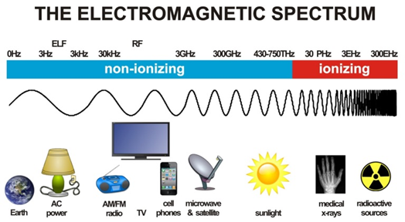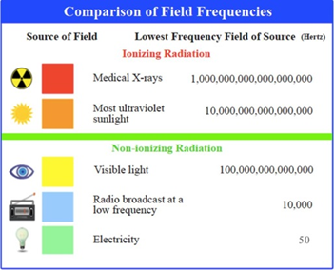

Electric fields
Electrical energy involves ‘voltage’, which is the pressure behind the flow of electricity and produces an electric field, and ‘current’, which is the quantity of electricity flowing and produces a magnetic field. An electric field is proportional to the voltage, which generally remains constant as long as the equipment is energised. The higher the voltage is, the higher the electric field. Even if the appliance is ‘off’ and the power point is ‘on’ an electric field will be present as the cord remains energised.
Electric fields are shielded by most objects, including trees, buildings and human skin. Their strength reduces quickly as you move away from the source.
The units commonly used to describe electric field strength are volts per metre (V/m) or kilovolts (1,000 Volts) per metre (kV/m).

Magnetic fields
Whenever an electric charge moves (i.e. whenever an electric current flows) a magnetic field is created that is proportional to the current - the higher the current, the higher the magnetic field.
Magnetic fields are often described in terms of their flux density which is commonly measured in units of Tesla (T) or the older unit of Gauss (G) where:
10,000 Gauss (G) = 1 Tesla (T) = 1,000,000 microT (µT)
1 µT = 10 mG
When a piece of equipment is completely turned off, there is no flow of current and so there is no magnetic field.
Like electric fields, the strength of magnetic fields drops quickly as you move away from the source. Unlike electric fields, magnetic fields cannot easily be shielded and pass through most materials.
How magnetic field decrease with distance
All magnetic fields decrease with distance from the source. Generally at a distance from the source, the fields will decrease as follows:
- Single current – 1/n
- Single circuit or double circuit un-transposed – 1/n2
- Double circuit transposed or coil – 1/n3
Figure 3-2 shows this rate of decrease from different sources. In practice, factors such unequal currents, zero sequence currents, very close proximity to sources and conductors not being exactly vertical will alter these curves. Further, magnetic field profiles are typically shown horizontally along the ground rather than towards the conductors.
Figure 3-2 Rate of decrease of magnetic fields from different sources
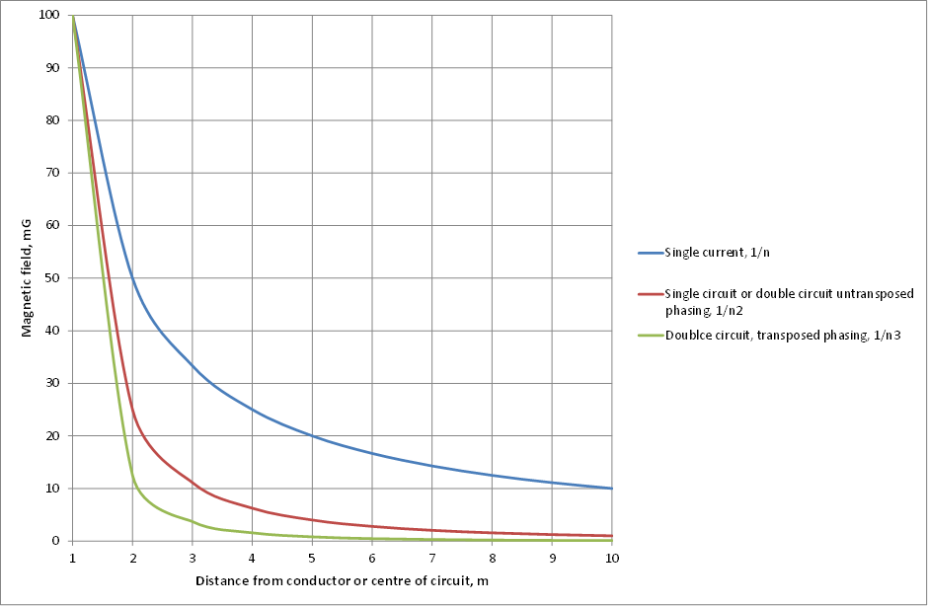
* Note: Hypothetical examples where magnetic fields are 100mG at 1m from the source.

Typical field levels in the environment
While powerlines tend to dominate background levels close to the line, household wiring, appliances and earth return currents tend to be the dominant source of magnetic fields in most homes. A person’s exposure is a function of background fields in the home, environment and workplace and fields from sources such as, , appliances, powerlines, earthing systems, substations, transport systems and anything that uses electricity.
Appliances
Typical magnetic field measurements associated with various appliances is shown in Table 3-1.
Table 3-1 Magnetic field measurements and ranges associated with various appliances.
Magnetic Field Source | Range of Measurement (in mG)  (normal user distance)
Electric stove | 2 – 30
Refrigerator | 2 – 5
Electric kettle | 2 – 10
Toaster | 2 – 10
Television | 0.2 – 2
Personal computer | 2 – 20
Electric blanket | 5 – 30
Hair dryer | 10 – 70
Pedestal fan | 0.2 – 2
* Note: Levels of magnetic fields may vary from the range of measurements shown.
Source: ARPANSA, Measuring magnetic fields.
Powerlines
Typical magnetic field measurements associated with powerlines is shown in Table 3-2.
Table 3-2 Typical values of magnetic fields measured near powerlines.
Source | Location of measurement | Range of measurements (mG)*
Distribution Line | directly underneath | 2 - 30
Distribution Line | 10m away | 0.5 - 10
Transmission line | directly underneath | 10 - 200
Transmission line | at edge of easement | 2 - 50
* Note: Levels of magnetic fields may vary from the range of measurements shown.
Source: ARPANSA, Measuring magnetic fields.
More information on electrical loading is provided in Appendix 4.

Substations
Large substations such as zone and transmission substations vary greatly in size, configuration and loading. Key sources of magnetic fields include the transformer secondary terminations, cable runs to the switch room, capacitors, reactors, bus-bars, and incoming and outgoing feeders. In most cases the highest magnetic fields at the boundary come from the incoming and outgoing transmission lines.
For distribution substations, the key sources of magnetic fields tend to be the low voltage boards, busbars and transformer cables. In most cases the magnetic field has decreased to background levels within a few metres of the substation. For this reason distribution substations are not a significant source of exposure. Exceptions could include chamber type substations which are typically installed in or adjacent to a building. In these cases the magnetic field exposure will be dependent on the configuration and loading of the substation and uses of adjacent areas (including above and below the substation).

Magnetic field sources around the home
As noted above, electrical appliances in the home produce EMF. In most cases, fields from appliances have decreased to background levels within one or two metres from the appliance. Magnetic fields from appliances generally decrease with the inverse cube of distance from the source.
The highest fields tend to come from motors or transformers designed for lightweight appliances. The peak field adjacent to some appliances can be higher than 1,000mG.
Other high sources of exposure could include items such as the meter box or electric blankets. The meter box where all current enters and leaves the house can have an elevated magnetic field to within a few metres of the box. These sources could result in elevated exposure if for example the bed head is near the meter box or the electric blanket is left on while in use.
Elevated fields may also occur as a result of the Multiple Earth Neutral (MEN) system used in Australia. With MEN systems, the earth and neutral are connected at the meter box and this is required for safety reasons. Some neutral current will return to the substation through the ground. This path could include the earth conductor, the ground and metallic services such as water pipes. As the earth return current is away from the active and neutral conductors, the fields from these net currents decrease with the inverse of the distance and can sometimes be a significant source. This is particularly the case if the service line neutral connection becomes loose or broken.
Figure 3-3 Example of MEN system
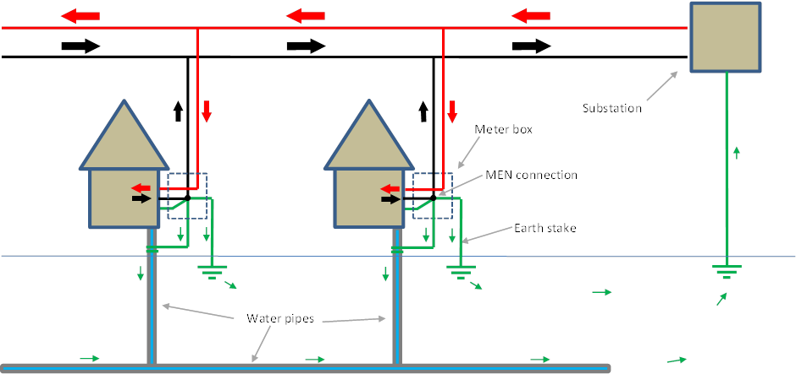

IMPORTANT NOTE: The MEN system performs a critical safety function. Unauthorised modifications to any aspect of the earthing system in an attempt to reduce magnetic fields could create a potentially fatal electrical hazard. All electrical work must be performed by a licenced electrician in accordance with specific rules and regulations. Further, if the neutral conductor becomes loose or broken, 'tingles' or electric shocks may be felt when touching appliances or water pipes and if this is the case these should be reported immediately and the appliances/pipes not touched until checked by the network operator or a licenced electrician.
Household wiring generally produces low magnetic fields as the active and neutral wires are run together and the fields largely cancel out. However, there are exceptions:
- Circuits that are wired so that the current flows in cables that are not close together.
- Some older types of underfloor heating (most new systems are designed with the active and neutral together)
- Two-way switching of lights where the cables are not installed together (see Figure 3-4).
- Accidental connections between the neutral and earth within the home. This could be because of unauthorised wiring, corrosion, incorrect wiring of an appliance or damage to the neutral insulation.
Figure 3-4 High EMF and Low EMF wiring of two way switches
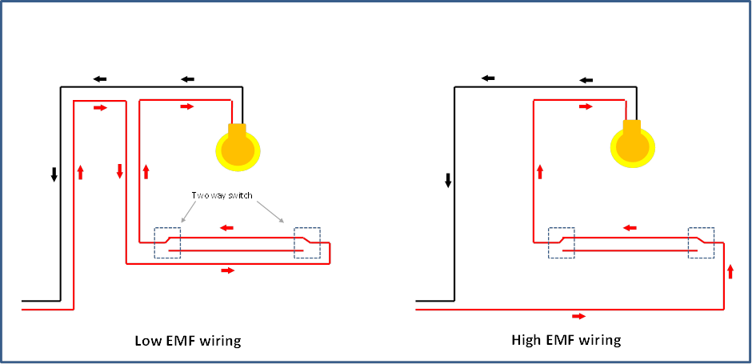
While not strictly sources around the home, electrical transport systems and mobile phones can also be other sources of high fields. While mobile phones transmit radiofrequency energy, their batteries produce pulses of current to power the transmission. These pulses of current produce magnetic fields at similar frequencies to 50Hz.

High field occupational environments
The magnitude of EMF produced by electrical equipment is dependent of the size of the source, its configuration, the voltage and current, and proximity.
Examples of situations where high magnetic fields could be encountered include close proximity to:
- air cored reactors (substation workers)
- busbars, low voltage boards, transformer secondary terminations, motors (substation workers)
- cables carrying large currents especially in pits and tunnels (substation workers, jointers)
- conductors carrying large currents (line workers)
- appliances with transformers and motors
- high current testing (testers)
- earthing conductors carrying large currents (substation workers)
Figure 3 5 Examples of high field environments
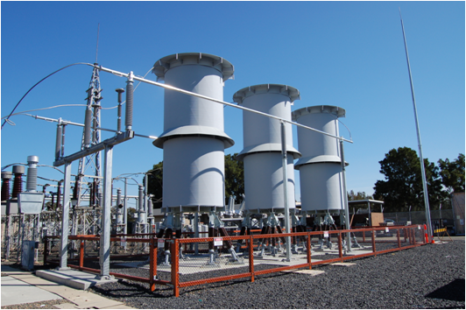  Air cored reactors | 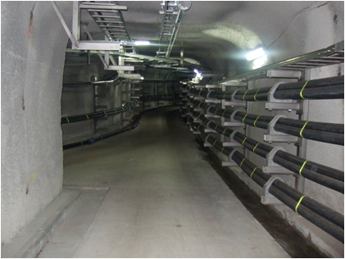  Cable tunnels | 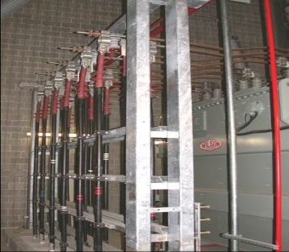  Transformer secondaries
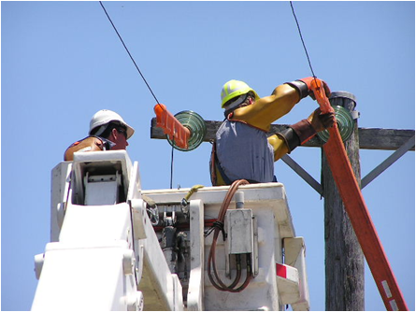  Live line work | 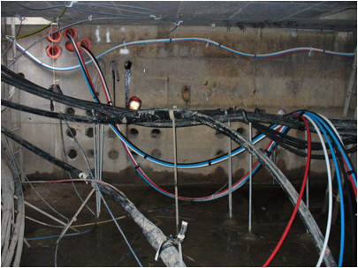  Cable pits and basements | 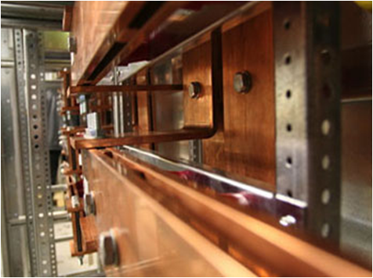  Busbars, LV boards
Examples of situations where high electric fields could be encountered include:
- directly under 220kV and greater overhead power transmission lines (live line workers)
- directly under substation busbars (substation workers)
- close proximity to high voltage conductors (live line workers)

FURTHER INFORMATION
ARPANSA Measuring magnetic fields. See more at www.arpansa.gov.au
WHO What are electromagnetic fields. See more at www.who.int
UK National Grid EMF Information website. See more www.emfs.info

THE SCIENCE OF EMF AND HEALTH
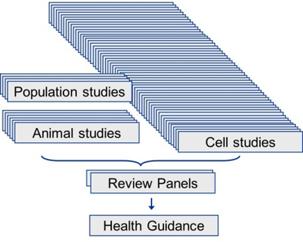
The question of EMF and health has been the subject of a significant amount of research since the 1970’s. This large body of scientific research includes both epidemiological (population) and laboratory (at both a cellular and an organism level) studies.
Research into EMF and health is a complex area involving many disciplines, from biology, physics and chemistry to medicine, biophysics and epidemiology.
EMF at levels above the exposure guidelines can cause both synaptic effects perceived as magneto-phosphenes in the sensitive retinal tissue (magnetic fields) and micro-shocks (electric fields). The exposure guidelines are in place to protect against these effects (see Section 5).
No single study considered in isolation will provide a meaningful answer to the question of whether or not EMF can cause or contribute to adverse health effects. In order to make an informed conclusion from all of the research, it is necessary to consider the science in its totality. Over the years, governments and regulatory agencies around the world have commissioned many independent scientific review panels to provide such overall assessments.

Conclusions FROM public health authorities
As part of the Health and Aging Portfolio, Australian Radiation Protection and Nuclear Safety Agency (ARPANSA) is a Federal Government agency charged with the responsibility for protecting the health and safety of people, and the environment, from EMF.
ARPANSA advises that:
“The scientific evidence does not establish that exposure to ELF EMF found around the home, the office or near powerlines and other electrical sources is a hazard to human health"
“The scientific evidence does not establish that exposure to the electric and magnetic fields found around the home, the office or near powerlines causes health effects. However, there are some epidemiological (population) studies that have reported a possible association between prolonged exposure to ELF magnetic fields at levels higher than typical and increased rates of childhood leukaemia. Other research including studies on cells and animals has not confirmed these results. On balance, the evidence related to childhood leukaemia is not strong; however people should be aware of the issue in order to make informed decisions.”
These findings are consistent with the views of other credible public health authorities. For example, the World Health Organization (WHO) advises that:
“Despite the feeling of some people that more research needs to be done, scientific knowledge in this area is now more extensive than for most chemicals. Based on a recent in-depth review of the scientific literature, the WHO concluded that current evidence does not confirm the existence of any health consequences from exposure to low level electromagnetic fields.”
“…..it is not recommended that the limit values in exposure guidelines be reduced to some arbitrary level in the name of precaution. Such practice undermines the scientific foundation on which the limits are based and is likely to be an expensive and not necessarily effective way of providing protection.”
Similarly, the U.S. National Cancer Institute concludes that
“Currently, researchers conclude that there is little evidence that exposure to ELF-EMFs from power lines causes leukemia, brain tumors, or any other cancers in children.”
“No mechanism by which ELF-EMFs could cause cancer has been identified. Unlike high-energy (ionizing) radiation, ELF-EMFs are low energy and non-ionizing and cannot damage DNA or cells directly.”
“Studies of animals exposed to ELF-EMFs have not provided any indications that ELF-EMF exposure is associated with cancer, and no mechanism has been identified by which such fields could cause cancer.”
Health Canada, the Canadian national public health authority advises that
“There have been many studies on the possible health effects from exposure to EMFs at ELFs. While it is known that EMFs can cause weak electric currents to flow through the human body, the intensity of these currents is too low to cause any known health effects. Some studies have suggested a possible link between exposure to ELF magnetic fields and certain types of childhood cancer, but at present this association is not established.”
“The International Agency for Research on Cancer (IARC) has classified ELF magnetic fields as "possibly carcinogenic to humans". The IARC classification of ELF magnetic fields reflects the fact that some limited evidence exists that ELF magnetic fields might be a risk factor for childhood leukemia . However, the vast majority of scientific research to date does not support a link between ELF magnetic field exposure and human cancers. At present, the evidence of a possible link between ELF magnetic field exposure and cancer risk is far from conclusive and more research is needed to clarify this "possible" link.”
International Commission On Non-Ionizing Radiation Protection - 2010
“It is the view of ICNIRP that the currently existing scientific evidence that prolonged exposure to low frequency magnetic fields is causally related with an increased risk of childhood leukemia is too weak to form the basis for exposure guidelines. In particular, if the relationship is not causal, then no benefit to health will accrue from reducing exposure.”

FURTHER INFORMATION:
ARPANSA EMF Fact sheets. See more at www.arpansa.gov.au
WHO EMF Fact sheets – About electromagnetic fields. See more at www.who.int
ICNIRP. See more at www.icnirp.org
U.S. National Cancer Institute. See more at www.cancer.gov
Health Canada. See more at healthycanadians.gc.ca
International Agency for Research on Cancer. See more at www.iarc.fr

EMF GUIDELINES AND EXPOSURE LIMITS
The two internationally recognised exposure guidelines are ICNIRP and IEEE.
- International Commission on Non-Ionizing Radiation Protection (ICNIRP) 2010
- Institute of Electrical and Electronics Engineers (IEEE) in the USA 2002.
ARPANSA’s current advice is “The ICNIRP ELF guidelines are consistent with ARPANSA’s understanding of the scientific basis for the protection of people from exposure to ELF EMF.”
The WHO (2007) advises:
“Health effects related to short-term, high-level exposure have been established and form the basis of two international exposure limit guidelines (ICNIRP, 1998; IEEE, 2002). At present, these bodies consider the scientific evidence related to possible health effects from long-term, low-level exposure to ELF fields insufficient to justify lowering these quantitative exposure limits.”
The above exposure guidelines express limits in terms of Basic Restrictions and Reference Levels for both magnetic field and electric fields under General Public and Occupational exposure conditions.
The magnetic field exposure limits are intended to prevent the occurrence of synaptic effects perceived as magneto-phosphenes in the sensitive retinal tissue. Since this phenomenon is related to synaptic effects in specialised neural tissue, and since similar effects could possibly occur elsewhere in the central nervous system, particularly the brain, and the expert groups have advised that any exposure involving the head should be below this level.
The electric field exposure limits are intended to protect against synaptic effects (ICNIRP) and micro-shocks (IEEE). Micro-shocks may involve a spark discharge that occurs either immediately before making contact with a grounded conductor, or when a grounded person touches a charged isolated conductor. The public exposure level is similar to that experienced from spark discharges when touching, for example, a door handle after acquiring static from crossing a carpet or getting out of a car seat.
Occupational exposure is defined as follows:
ICNIRP 2010:
“Occupational exposure in these guidelines refers to adults exposed to time-varying electric, and magnetic fields from 1 Hz to 10 MHz at their workplaces, generally under known conditions, and as a result of performing their regular or assigned job activities. By contrast, the term general population refers to individuals of all ages and of varying health status which might increase the variability of the individual susceptibilities. In many cases, members of the public are unaware of their exposure to EMF. These considerations underlie the adoption of more stringent exposure restrictions for the public than for workers while they are occupationally exposed."
IEEE 2002:
“An area that is accessible to those who are aware of the potential for exposure as a concomitant of employment, to individuals cognizant of exposure and potential adverse effects, or where exposure is the incidental result of passage through areas posted with warnings, or where the environment is not accessible to the general public and those individuals having access are aware of the potential for adverse effects.”
Basic restrictions
Basic restrictions are the fundamental limits on exposure and are based on the internal electric currents or fields that cause established biological effects. The basic restrictions are given in terms of the electric fields and currents induced in the body by the external fields. If Basic Restrictions are not exceeded, there will be protection against the established biological effects.
The Basic Restrictions include safety factors to ensure that, even in extreme circumstances, the thresholds for these health effects are not reached. These safety factors also allow for uncertainties as to where these thresholds actually lie. The physical quantity used to specify the Basic Restrictions is the tissue induced electric field. The Basic Restrictions relating to 50Hz are shown in Table 5 1.
Reference Levels
The Basic Restrictions in the ICNIRP and IEEE Guidelines are specified through quantities that are often difficult and, in many cases, impractical to measure. Therefore, Reference Levels of exposure to the external fields, which are simpler to measure, are provided as an alternative means of showing compliance with the Basic Restrictions. The Reference Levels have been conservatively formulated such that compliance with the Reference Levels will ensure compliance with the Basic Restrictions. If measured exposures are higher than Reference Levels then a more detailed analysis would be necessary to demonstrate compliance with the Basic Restrictions.
Table 5 2 and Table 5 3 specify the Reference Levels for exposure to magnetic fields and electric fields respectively at 50 Hz.

Summary of Basic Restrictions
The following table summaries the basic restrictions for IEEE and ICNIRP.
Table 5-1 Basic restrictions at 50Hz for IEEE and ICNIRP.
 | IEEE  2002 | ICNIRP  2010
GENERAL PUBLIC
Exposure to head | 0.0147 V/m | 0.02 V/m
Exposure elsewhere | 0.943 V/m (heart)  2.10 V/m (hands, wrists, feet)  0.701 V/m (other tissue) | 0.4 V/m (rest of body)
OCCUPATIONAL
Exposure to head | 0.0443 V/m | 0.1 V/m
Exposure to rest of body | 0.943 V/m (heart)  2.10 V/m (hands, wrists, feet, other tissue) | 0.8 V/m (rest of body)

Summary of Reference Levels
The following tables summarise the magnetic field exposure Reference Levels for IEEE and ICNIRP.
Table 5 2 Magnetic field Reference Levels at 50Hz for IEEE and ICNIRP.
 | IEEE  2002 | ICNIRP  2010
GENERAL PUBLIC
Exposure - general | Not specified | 2,000 mG*
Exposure to head and torso | 9,040 mG | Not specified
Exposure to arms and legs | 758,000 mG | Not specified
OCCUPATIONAL
Exposure - general | Not specified | 10,000 mG*
Exposure to head and torso | 27,100 mG | Not specified
Exposure to arms and legs | 758,000 mG | Not specified

* ICNIRP advises that it is reasonable in certain circumstances for workers to experience transient effects such as retinal phosphenes. In this regard the EU Directive 2013/35/EU includes low action levels (ICNIRP levels) and high action levels of 6,000µT and 18,000µT (limbs). Action levels can be exceeded if certain measures are in place such as assessments, action plans and access to information. The measures required depend on the level.
The following table summarises the electric field Reference Levels for relevant Australian and international exposure guidelines.
Table 5-3 Electric field Reference Levels at 50Hz for IEEE and ICNIRP
 | IEEE  2002 | ICNIRP  2010
GENERAL PUBLIC
Exposure | 5 kV/m  10kV /m (within right of way) | 5 kV/m
OCCUPATIONAL
Exposure | 10 kV/m  20kV /m (within right of way) | 10 kV/m
FURTHER INFORMATION
ICNIRP Guidelines – 2010 – For Limiting Exposure to Time – Varying Electric and Magnetic Fields (1 HZ – 100 KHZ). Se more at www.icnirp.org
IEEE C95.6™-2002 – Safety Levels with Respect to Human Exposure to Electromagnetic Fields, 0-3 kHz - See more at: www.ices-emfsafety.org/

METHODS FOR ASSESSING COMPLIANCE WITH EXPOSURE LIMITS
ENA’s policy includes designing and operating electricity generation, transmission and distribution systems in compliance with relevant Australian exposure guidelines and consistent with the concept of Prudent Avoidance.
The concept of prudent avoidance is discussed in Section 7.
Relevant Australian and international health guidelines are discussed in Section 5.
In general, electric and magnetic fields from electricity assets will be well below the Reference Levels in these guidelines and specific compliance assessments will not be required. Exceptions could include specific occupational activities in close proximity to assets such as very highly loaded conductors, air cored reactors or air cored transformers. For this reason, the rest of this section focuses on occupational exposure.
A compliance assessment can be used to demonstrate compliance with relevant Australian and international guidelines and, in particular, the Reference Levels or Basic Restrictions.
Where an assessment is required, it could be in the form of:
- review of work practices against minimum compliance distances
- measurements or simple calculations or modelling to demonstrate compliance against the Reference Levels, or
- modelling to demonstrate compliance against the Basic Restrictions.
The overall process for a compliance assessment is shown in Figure 6-1.

Figure 6-1 Process for assessing compliance with exposure limits

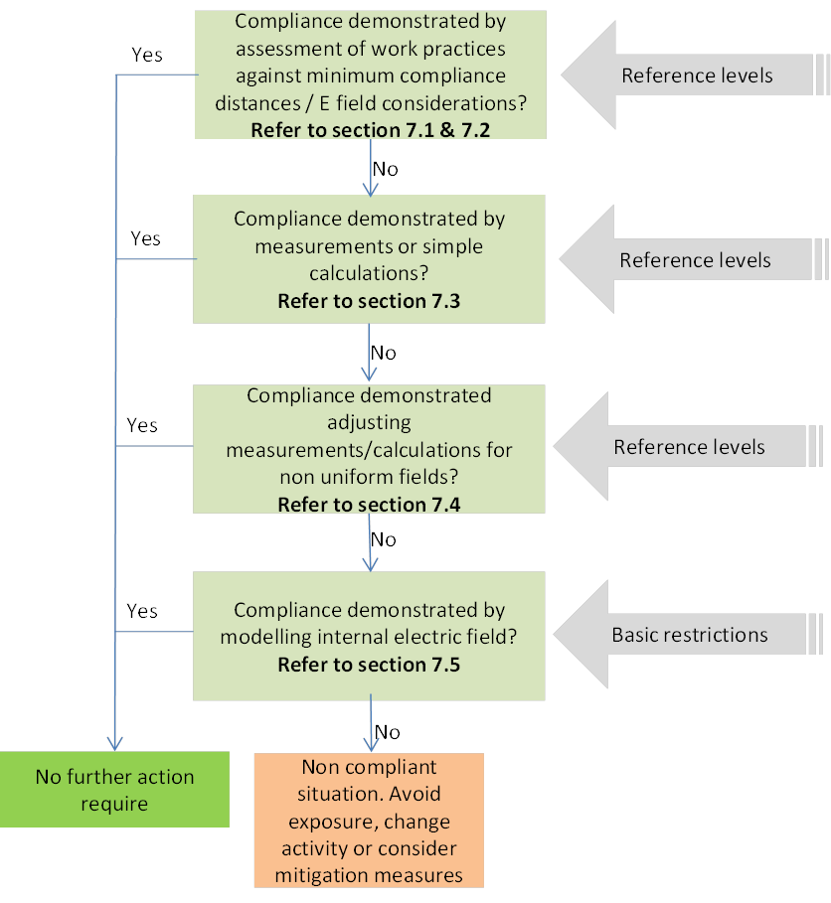

Magnetic field sources – minimum compliance distances
The methodology in Section 6.1 and Section 6.2 is taken from BS EN 50499:2008 – Procedure for the assessment of the exposure of workers to electromagnetic fields.
Conductors
Compliance with Reference Levels (see Section 5.2) can be demonstrated by showing that people are at a distance larger than the minimum compliance distance as shown in Table 6-1. The minimum distance is calculated by the following equation:
Dmin = 2 I / BLim where D is the distance in metres, I is the current in Amps and BLim is the exposure limit in milligauss.
Table 6 -1 Minimum compliance distance to the centre of a single conductor (ICNIRP Reference Levels).

Current in conductor  A | Distance to exposure limit (B_{Lim} = 2,000mG)  M | Distance to exposure limit (B_{Lim} = 10,000mG)  M
100 | 0.1 (Compliant*) | 0.02 (Compliant*)
200 | 0.2 (Compliant*) | 0.04 (Compliant*)
500 | 0.5 | 0.1 (Compliant*)
1,000 | 1.0 | 0.2 (Compliant*)
1,500 | 1.5 | 0.3
2,000 | 2.0 | 0.4
2,500 | 2.5 | 0.5
5,000 | 5.0 | 1.0
* For distances closer to 0.2m, BS EN 50499:2008 (with BLim = 5,000mG) states:
Closer to the conductor, considerations relating to the non-uniformity of the field (see EN 62226-1), the diameter of conductor necessary to carry the current and numerical computation of induced current density in the body for uniform field (Dimbylow, 2005), have the consequence that for currents up to 500 A the exposure limit will always be complied with however close together the body and conductor are.
Note: The IEEE 2002 Standard has Reference Levels of 9,040mG (public) and 27,100mG (occupational) and a limit of 758,000 mG for limbs. Minimum compliance distances for these Reference Levels are not shown in the table above. See Section 5 for more information on exposure limits.
The above approach can be conservatively applied to three phase circuits, bundled circuits and multiple circuits. Where there are multiple circuits and the separation of conductors is small, an assessment of the net current can be used.
Worked example:
An assessment is undertaken to determine the compliance distance to a three phase cable in relation to the ICNIRP occupational exposure limit.
The exposure limit for occupational exposure is 10,000mG (ICNIRP 2010).
It can be seen from Table 6-1 that a current of 1,000A corresponds with a minimum compliance distance of 0.2m from the centre of the single conductor for BLim = 10,000mG. As stated above, this is a conservative calculation for 3 phase cables.
Therefore exposure to any three phase cable (or single conductor) carrying up to 1,000A is intrinsically compliant with the ICNIRP exposure limit of 10,000mG regardless of distance to the source.
Where cables or conductors carry more than 1,000A, then the minimum compliance distances in Table 6-1 should be maintained or one of the following should be applied:
- Apply mitigation measures to reduce exposure (see Section 9),
- Change work practices to allow for the use of an alternative Reference Level (see Section 5.2) or
- Undertake further detailed assessment (see Figure 6-1).
Equipment
Very few pieces of equipment can produce magnetic fields in excess of the Reference Levels at a distance of 0.2m or more. Such items could include air cored transformers or reactors. Items where this is likely to happen will need to be assessed by calculations, measurements or modelling.
Conventional iron-cored devices have low external magnetic field leakage which will not normally be sufficient to exceed the Reference Levels.

Electric field sources - considerations
Overhead bare conductors with a voltage over 200kV, may under some circumstances produce an electric field in excess of the Reference Levels. This is particularly the case for live line workers in close proximity to the very high voltage conductors.
Such situations are typically managed with Faraday suits (occupational exposure) and the provision of information, earthing, and screening (public exposure).
The management of these situations will depend on the construction, geography and nature of exposure and specific rules cannot be prescribed in this Handbook.

Calculations or measurements of external fields
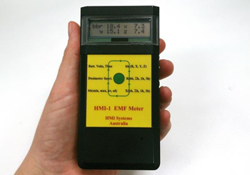
Calculations or measurements to demonstrate compliance with guidelines should be made by an appropriately qualified and experienced person or authority.
Calculations are the preferred method of assessment for situations involving simple elements such as powerlines. Calculations have the advantage of enabling the assessor to define and control input variables and to assess a range of loading conditions rather than being limited to the particular conditions at the time.
Measurements can be useful for assessing complex situations such as those associated with live line work, cable pits and LV boards. In these cases, extrapolation may be required to take account of the maximum potential load of the circuits.
For an overhead line the minimum design clearances should be used.
Further information about measuring EMF is contained in Appendix 3.
    - Loading conditions for exposure assessment calculations
The loading used for calculations in the context of compliance with guideline exposure limits should be the worst case over the foreseeable life of the asset. In most cases this will require use of the short term emergency loading. Measurements should be extrapolated to this loading, although certain assumptions and specialist knowledge may be required where there are complex or multiple sources.
More information on electrical loading is provided in Appendix 4.
    - Exposure limit reference point
Where the field is considered to be generally uniform, the electric or magnetic field level at the point of interest should be measured at 1 m above the ground. This is a generally accepted practice and is supported by standards such as IEEE, 2010, IEEE Recommended Practice for Measurements and Computations of Electric, Magnetic, and Electromagnetic Fields with Respect to Human Exposure to Such Fields, 0 Hz to 100 kHz.
Where exposure occurs in very close proximity to high current, non-uniform/complex fields, the reference point should be those area areas reasonably accessible. Such situations may include live-line work, high power testing, or work in cable pits/basements and tunnels.
In these cases, ‘reasonably accessible’ should take into account factors such as working procedures, barriers, and any specific factors relevant to the assessment. In most cases a distance of 0.2m from the source within the area of exposure is a conservative approach for performing measurements/calculations (See Section 6.1).
For many occupational activities, placing the meter in the chest or waist pockets is considered a practical, efficient, and reliable means of estimating maximum magnetic-field exposures in electric utility environments.

Adjustments for highly localised non-uniform fields
Where the maximum calculated or measured fields exceed the Reference Levels and the fields are highly localised, the following methods could be considered to assess compliance.
1. Monitor using a spatial averaging meter (Section 6.4.1)
2. Applying the magnetic field induction factor (Section 6.4.2)
Where the results of these methods exceed the Reference Levels then modelling of the internal electric field could be considered (Section 6.5).
    - Spatially averaging meter
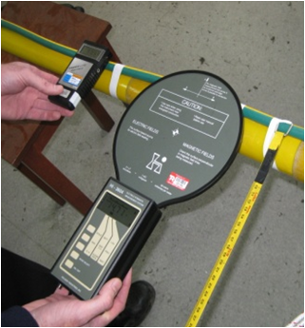
The Holaday HI-3604 is a commercially available magnetic field meter which has a sensing coil with a diameter of 16.5cm (radius 8.25 cm), which is about the same diameter as the head.
The Holaday HI-3604 has been shown to provide a very good correspondence between its measured magnetic field and the induced electric field from a single phase cable for head exposure. As such the Holaday meter provides a very good surrogate for induced electric field compliance for single cables, but may slightly underestimate compliance distances for cable bundles with balanced current.
Note that the magnetic sensor coil inside the Holaday HI 3604 is a single axis coil and is around 2cm from the nearest edge of the paddle. These factors should be taken into account when making measurements.
    - Magnetic field induction factor method
Maximum exposure measurements in non-uniform fields are higher than their equivalent uniform field exposures. Where measurements or calculations exceed the Reference Levels, the following approach may be applied.
Note: this method is not suitable when undertaking measurements using the Holaday meter.
However, before adopting this approach, the high-field work environments in question should be surveyed to demonstrate that they can, in fact, be characterized by fields that decrease inversely with the distance or more rapidly. Where there are multiple conductors (such as a cable pit) the environment can generally be categorised by fields that decrease inversely with the distance or faster provided that the cable diameters are greater than 3cm.
To determine compliance using this technique, it is necessary to calculate the equivalent uniform magnetic field and compare this against the relevant Reference Level.
The equivalent uniform magnetic field that produces the same peak magnetic field as a non-uniform field with a known maximum field can be derived using induction factors.
The derivation requires the following information:
1. Maximum measured/calculated exposure, MF
2. Distance from the assumed line source where the maximum exposure occurs, d
3. Relevant normalised induction factor F(d) based on distance from a line source (Figure 6-2)
4. Relevant Reference Level, RL.
To calculate the Equivalent Uniform Field, multiply the maximum exposure measurement by the Normalised Induction Factor (Figure 6-2).
Compliance is achieved if the following holds true:
RL > MF x F(d)
As stated by Bracken and Dawson (2004):
“Normalized induction factors referenced to surface maximum field represent a stable method for comparing non-uniform maximum fields at the surface of the body with field limits for uniform fields. Their use accurately incorporates a comparison of the peak induced electric field with the basic restriction.”
The procedures developed here apply to non-uniform field exposures where the magnetic field decreases as the inverse of distance or more rapidly. Under these conditions the maximum fields at the surface of the body that will meet the basic restriction criteria of guidelines are greater than those for uniform field exposures.
Worked example:
An activity requires the head to come within 30cm of a very highly loaded single core cable. Theoretical calculations show that the magnetic field (decreasing at 1/d) is 5,000mG at 30cm from the cable. Using the magnetic field induction factor, it can be shown that the equivalent uniform field is 0.84 x 5,000 = 4,200mG.

Figure 6-2 Normalised induction factor to calculate the equivalent uniform field after Bracken and Dawson (2004)
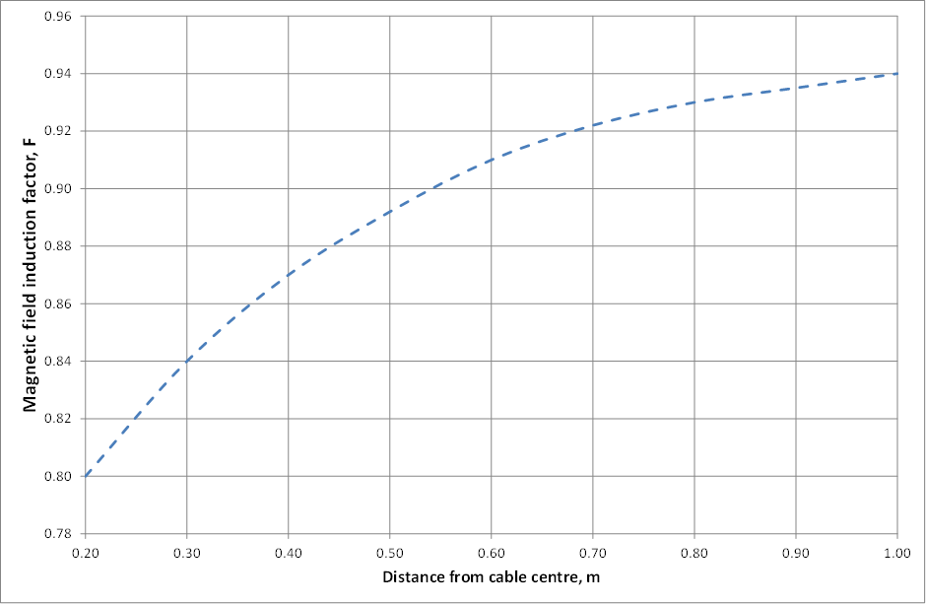
Ref: Bracken, TD, and Dawson T, 2004, Evaluation of Non-uniform 60 Hz Magnetic-Field Exposures for Compliance with Guidelines, J Occ Envir Hyg, 1, 629 – 638

Modelling internal electric field
Where measurements or simple calculations have been unable to establish compliance, approaches involving modelling of the internal electric field for comparison with the Basic Restriction could be considered.
If compliance is to be demonstrated by comparison with Basic Restrictions, the combined effect of both electric and magnetic external fields should be taken into account.
    - Simple modelling
Simple modelling calculations can be undertaken in accordance with appropriate IEC Standards, eg IEC 62226.
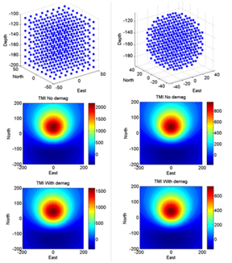
A comprehensive study using simple modelling has been performed by Anderson (2009) using the IEC62226-1 Model. This has provided calculations of internal electric and magnetic field compliance distances for the configuration of a horizontal wire conductor or two balanced parallel wires and a vertical human body. These results have been used to determine the compliant conditions and may be useful for determining compliance in other more specific situations.

    - Complex modelling
Where compliance cannot be demonstrated using measurements, calculations or simple modelling, compliance with the Basic Restrictions may need to be demonstrated via a complex modelling approach. Approaches could include complete numerical (voxel) models of appropriate representative body shapes. Advice from experts in this field should be sought. Papers using this approach have been published from various overseas research centres, for example the work of Peter Dimbylow at the UK Health Protection Agency.
Dosimetry modelling by Dimbylow (2005) has been used to calculate the external electric and magnetic fields required to exceed the ICNIRP 2010 Basic Restrictions (see Table 6-2).
Table 6-2 Dosimetry for ICNIRP 2010 exposure guidelines.
 | ICNIRP Reference Level | Dosimetric modelling
GENERAL PUBLIC |  | Dosimetric conversion factor |  | Calculated external field
Magnetic field | 2,000mG | 33 mV/m / mT |  | 6,060mG
Electric field | 5 kV/m | 2.02 mV/m / kV/m |  | 9.9 kV/m
OCCUPATIONAL
Magnetic field | 10,000mG | 33 mV/m / mT | 30,300mG
Electric field | 10 kV/m | 33.1 mV/m / kV/m | 24.2 kV/m
While the Dimbylow modelling confirms that the INCIRP Reference Levels are indeed conservatively formulated, the first step should always be to demonstrate compliance with the exposure limits by conventional means and where practicable, avoid exposure by engineering or administrative controls.
Where compliance cannot be demonstrated by any of the above means and exposure cannot be mitigated to compliant levels then the exposure should be avoided.

FURTHER INFORMATION
Anderson, V, 2009, B field compliance for 50 Hz live line work, Swinburne University, 2 September 2009
Bracken, TD, and Dawson, T, 2004, Evaluation of Non- uniform 60 Hz Magnetic-Field Exposures for Compliance with Guidelines, J Occ Envir Hyg, 1, 629 – 638
BS EN 50499:2008 – Procedure for the assessment of the exposure of workers to electromagnetic fields
Dawson, TW, Caputa, K and Stuchley, MA, 1999, Numerical evaluation of 60 Hz magnetic induction in the human body in complex occupational environments. Phys Med Biol, 44, 1025-1040
Dawson, TW, Caputa, K and Stuchley, MA, 2002, Magnetic field exposures for UK live-line workers. Phys Med Biol, 47, 995-1012
Dimbylow, P and Findlay, R, 2009, The effects of body posture, anatomy, age and pregnancy on the calculation of induced current densities at 50 Hz, Rad Prot Dos, advanced access published 23 December 2009
Dimbylow, P, 2005, Development of pregnant female voxel phantom, NAOMI< and its application to calculations of induced current densities and electric fields from applied low frequency magnetic and electric fields, Phys Med Biol 50 1047-1070
Dimbylow, P, 2006, Development of pregnant female, hybrid voxel-mathematical models and their application to the dosimetry of applied magnetic and electric fields at 50Hz. Phys Med Biol 51, 2383-2394
IEEE C95.3.1™-2010 – Measurements & Computations of Electric, Magnetic, and Electromagnetic Fields with Respect to Human Exposure to Such Fields, 0 Hz to 100 kHz - See more at: http://standards.ICES.org/
UK Department of Energy and Climate Change - 2012 - Power Lines: Demonstrating compliance with EMF public exposure guidelines - A voluntary Code of Practice – See more at www.gov.uk
IEC 62226-2-1, Exposure to electric and magnetic fields in the low to intermediate frequency range-Methods for calculating current density and internal electric fields in the human body. Part 2-1 Exposure to magnetic fields - 2D models.
IEC 61786, Measurement of low frequency magnetic and electric fields with regard to exposure to human beings – special requirements for instruments and guidance for measurements.
IEC 62110 Electric and magnetic field levels generated by AC power systems - Measurement procedures with regard to public exposure.
IEC 62311, Assessment of electronic and electrical equipment related to human exposure for electromagnetic fields (0-300Ghz)

PRUDENT AVOIDANCE / PRECAUTION
Since the late 1980s, many reviews of the scientific literature have been published by authoritative bodies. There have also been a number of Inquiries such as those by Sir Harry Gibbs in NSW and Professor Hedley Peach in Victoria. These reviews and inquiries have consistently found that:
- Adverse health effects have not been established.
- The possibility cannot be ruled out.
- If there is a risk, it is more likely to be associated with the magnetic field than the electric field.
Both Sir Harry Gibbs and Professor Peach recommended a policy of prudent avoidance, which Sir Harry Gibbs described in the following terms:
“…. [doing] whatever can be done without undue inconvenience and at modest expense to avert the possible risk …”
These recommendations have been adopted by the ENA and other electricity transmission and distribution businesses.

ENA position
The Energy Networks Association (ENA) is the peak national body for Australia’s energy networks. ENA represents gas and electricity distribution, and electricity transmission businesses in Australia on a range national energy policy issues.
ENA is committed to taking a leadership role on relevant environmental issues including power frequency EMFs. ENA and its members are committed to the health and safety of the community, including their own employees.
ENA’s position on EMF is that adverse health effects from EMFs have not been established, and there remains a lack of scientific consensus about whether they can occur. ENA nonetheless recognises that some members of the public continue to have concerns about EMFs and is committed to addressing it by the implementation of appropriate policies and practices.
Policy statement
- ENA recommends to its members that they design and operate their electricity generation, transmission and distribution systems in compliance with recognised international EMF exposure guidelines and to continue following an approach consistent with the concept of prudent avoidance.
- ENA will monitor engineering and scientific research, including reviews by scientific panels, policy and exposure guideline developments, and overseas policy development, especially with regard to the precautionary approach.
- ENA will communicate with all stakeholders including assisting its members in conducting community and employee education programs, distributing information material including newsletters, brochures, booklets and the like, liaising with the media and responding to enquiries from members of the public.
- ENA will cooperate with bodies established by governments in Australia to investigate and report about power frequency electric and magnetic fields.

Precaution – World Health Organization
In 2007, the WHO published their Extremely Low Frequency [ELF] Fields – Environmental Health Criteria Monograph No. 238. In relation to overall guidance to member states, WHO Organisation has addressed the notion of prudence or precaution on several occasions, including in its 2007 publication Extremely Low Frequency Fields, which states:
“…..the use of precautionary approaches is warranted. However, it is not recommended that the limit values in exposure guidelines be reduced to some arbitrary level in the name of precaution. Such practice undermines the scientific foundation on which the limits are based and is likely to be an expensive and not necessarily effective way of providing protection.”
It also states:
“[E]lectric power brings obvious health, social and economic benefits, and precautionary approaches should not compromise these benefits. Furthermore, given both the weakness of the evidence for a link between exposure to ELF magnetic fields and childhood leukaemia, and the limited impact on public health if there is a link, the benefits of exposure reduction on health are unclear. Thus the costs of precautionary measures should be very low.”
The Monograph further emphasises that “Even when allowing for the legitimate desire of society to err on the side of safety, it is likely that it will be difficult to justify more than very low-cost measures to reduce exposure to ELF fields.”
In the implementation of precaution, care should be taken not to over-state the risk and unnecessarily raise concern. WHO advise that precaution measures “should not compromise the essential health, social and economic benefits of electric power”.
For most practical purposes, precaution as defined by WHO is consistent with the industry’s long standing policy of prudent avoidance.

Summary of prudent avoidance / precaution principles
In summary, both prudent avoidance and the precautionary approach involve implementing no cost and very low cost measures that materially reduce exposure while not unduly compromising other issues.
The following key guiding principles can be applied to prudent avoidance / precaution in relation to EMF.
- Prudent avoidance / precaution involves monitoring research; reviewing policies in the light of the most up to date research findings (with particular emphasis on the findings of credible scientific review panels); providing awareness training for electricity supply business employees and keeping them informed and sharing information freely with the community.
- Measures to reduce exposure should be used if they can be implemented at ‘no cost’ or ‘very low cost’ and provided they do not unduly compromise other issues.
- Prudent avoidance / precaution does not operate in isolation but rather is one of many issues that need to be given due consideration in the design and operation of the electricity supply system.
- There is no reliable scientific basis for the adoption of arbitrary low exposure limits, setbacks or for a specific level at which precaution applies.
- Where exposure is consistent with typical background levels, the potential for further reductions is limited.
- Due to the large additional cost, undergrounding powerlines for reasons of EMF alone is clearly outside the scope of prudent avoidance / precaution.
- It cannot be said that the above measures will result in a demonstrable health benefit.
FURTHER INFORMATION:
WHO EMF Fact sheets. See more at www.who.int
ENA EMF Policy. See more at www.ena.asn.au

PROCESS FOR EVALUATING PRUDENT AVOIDANCE
ENA’s policy includes designing and operating electricity generation, transmission and distribution systems in compliance with relevant Australian guidelines and in an approach consistent with prudent avoidance.
No cost and very low cost measures that materially reduce exposure while not unduly compromising other issues should be adopted.
In most cases the application of prudent avoidance can be implemented on a project or incorporated into network standards without the need for a specific assessment. Specific assessments may be undertaken for major projects where a greater range of potential reduction options are available, or where specific investigations or environmental planning approval processes require such an assessment.
Where a specific assessment is required, the following guidance is provided to assist in that assessment.
This section assumes there will be compliance with the exposure limits (See Section 6).

General guidance on applying prudent avoidance
The guidance below is provided to assist in evaluating prudent avoidance measures where a specific assessment or further guidance is required.
    - Potential locations of interest
From a practical perspective, the focus of public attention to EMF issues and therefore areas considered more relevant in a precautionary context would include schools, childcare centres, and other places where children congregate, and residential areas.
The specific case of people with medical implants is dealt with in Section 10.
    - Exposure assessment
Determining actual exposure is complicated as magnetic fields from electrical infrastructure change in accordance with daily and seasonal loading profiles. Further, there may be multiple sources, sources change over time, and people are not stationary. Fortunately such a detailed assessment is not necessary for a prudent avoidance assessment.
Where there are existing magnetic fields of random orientation (such as appliances, ground currents, household wiring etc.) the largest source will dominate the result. This is because fields are vectors and it is not a simple matter of adding the fields. Further the application of prudent avoidance involves assessing exposure from what is proposed. For these reasons it is normal practice for such an assessment to ignore these other sources.
The focus of an exposure assessment in the context of prudent avoidance is on determining magnetic field exposure sufficient to be able to determine whether there are no cost and very low cost measures that materially reduce exposure while not unduly compromising other issues. This can often be achieved without the need for complex calculations and, in many cases, without calculations at all.
Loading conditions for prudent avoidance calculations
Where specific calculations are required the following guidance is provided.
With prudent avoidance assessments, which address the ability to reduce fields with no cost or very low cost measures, the reduction in exposure arising from potential measures is more relevant than the highest predicted magnetic fields (as would be the case for exposure limit assessments).
According to WHO (Ref 3):
“In the absence of a known biophysical mechanism, which would yield a known etiologically relevant metric of exposure, the metric of choice used in most epidemiological studies has been the time-weighted average.”
While loads of substations and powerlines will generally increase over time after commissioning, a conservative approach which takes into account daily and seasonal variations would be to calculate the time-weighted-average (TWA) over a complete year using loads shortly after commissioning and also in the year representing the maximum foreseeable projected TWA.
Where available loading information does not permit the calculation of TWA, it may be necessary to exercise judgement, based on the best available information to derive a load which represents at least a conservative approximation of TWA.
More information on electrical loading is provided in Appendix 4.
Ground clearance for overhead lines
Where specific calculations are required the following guidance is provided.
A conservative estimate of ground clearance for prudent avoidance assessments would be to assume 2/3 of the calculated sag for a typical span under typical ambient conditions for the year representing the maximum foreseeable projected loads.
Prudent avoidance assessment reference points
When undertaking a prudent avoidance assessment, the primary reference points for calculations should be those areas where people, especially children, spend prolonged periods of time. As the epidemiological studies typically use exposure within the home (often a child’s bedroom), and in the absence of data suggesting otherwise, a conservative approach for residential areas is to select the reference point as being the nearest part of any habitable room. There may be specific circumstances that dictate otherwise.
It is important not to over complicate the assessment or lose sight of the purpose – which is to determine no cost and very low cost measures that materially reduce exposure while not unduly compromising other issues.
The exception to this is non compliance with exposure limits (See Section 6) If the average exposure is less than or equal to typical background magnetic field levels, no further assessment is required.
    - Possible ways to reduce exposure
Exposure reduction can involve siting measures, which result in increased separation from sources and/or field reduction measures. Methods for mitigating magnetic fields are described in Section 9.
If there are no practical measures available to materially reduce magnetic field exposure, no further action is required.
    - Consideration of other issues
Measures to reduce magnetic field exposure must be considered against numerous other objectives and constraints of the project including:
- worker safety
- the location of the power source and the load to be supplied
- availability of suitable sites
- ease of construction and access
- reliability
- cost
- conductor heating
- the nature of the terrain
- maintenance requirements
- visual amenity
- provision for future development
- environmental impacts.
The goal of any project is to achieve the best balance of all of the project’s objectives, taking into account relevant social, technical, financial and environmental considerations.
If the available measures unduly compromise other issues, no further action is required.
    - Cost-benefit analysis
Sir Harry Gibbs and Professor Peach recommended a policy of prudence or prudent avoidance, which Sir Harry Gibbs described in the following terms:
“…. [doing] whatever can be done without undue inconvenience and at modest expense to avert the possible risk …”
The WHO, in its Environmental Health Criteria monograph on EMF, advises that:
“Provided that the health, social and economic benefits are not compromised, implementing very low cost precautionary procedures to reduce exposure is reasonable and warranted’ [WHO 2007].”
If the available mitigation measures cannot be implemented at no cost or very low cost then no further action is required.
No cost and very low cost measures that materially reduce exposure while not unduly compromising other issues should be adopted.
Worked examples are shown in Appendix 2.
FURTHER INFORMATION
TNSP Operational Line Ratings - March 2009
UK Department of Energy and Climate Change - 2012 - Optimum Phasing of high voltage double-circuit Power Lines A voluntary Code of Practice – See more at www.gov.uk
UK Energy Networks Association – 2013 - ER G92 Issue 1 - Guidelines for Best Practice in relation to Electric and Magnetic Fields (EMFs) in the Design and Management of Low Voltage Distribution Networks – See more at www.energynetworks.org

METHODS TO MITIGATE MAGNETIC FIELDS
This section describes options for mitigating magnetic fields from both powerlines and substations. Whether such measures fall within prudent avoidance would depend upon their effectiveness, the project objectives and constraints, the cost to implement and ultimately, the project specific circumstances (see Section 7).
There are several approaches that could be considered to mitigate magnetic fields from electrical infrastructure. The following three generic measures are generally the most practicable:
- Increasing the distance from source
- Modifying the physical arrangement of the source:
- reducing the conductor spacing
- optimising the phase configuration
- rearranging equipment layout and equipment orientation
- for low voltage, bundling the neutral conductor with other phases
- Minimising the current and balancing the phases
- demand management
- configuration of the load
Additional measures which are less likely to satisfy the cost and convenience criteria which apply to precautionary measures but may be considered include:
- Incorporating a suitable shielding barrier between the source and the receiver
- Active and Passive compensation and shielding

Overhead powerlines
The calculations shown in this section are indicative only and based on 132kV configurations unless specified otherwise. Phase separation, conductor heights and other significant factors such as line load will vary depending on component suppliers and project specifics. The following construction types are referred to in the calculations.

Figure 9-1 Different overhead construction configurations

H pole dual pole construction | Delta single pole construction | Vertical, single pole construction
 |  | 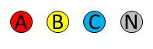
Double circuit construction, same phasing | Double circuit construction, reverse phasing (transposed) Spilt phasing | Low voltage (415V) construction
    - Distance
Where the line is to be sited in a road reserve, consideration can be given to selecting sides of the road which are less populated or utilising existing easements. Deviations in the route will need careful consideration of project cost and project constraints and objectives.
Raising the height of supporting structures or towers will generally reduce the magnetic field strength as a result of increased distance from the ground. However, the benefit of this measure is reduced with distance from the powerlines. This effect is shown in Figure 10-2. The increased cost, maintenance difficulties and visual presence associated with the increased structure height may limit this technique. In some cases, raising the height may increase the field strength at some locations.
Figure 9-2 Effect of raising the conductor height
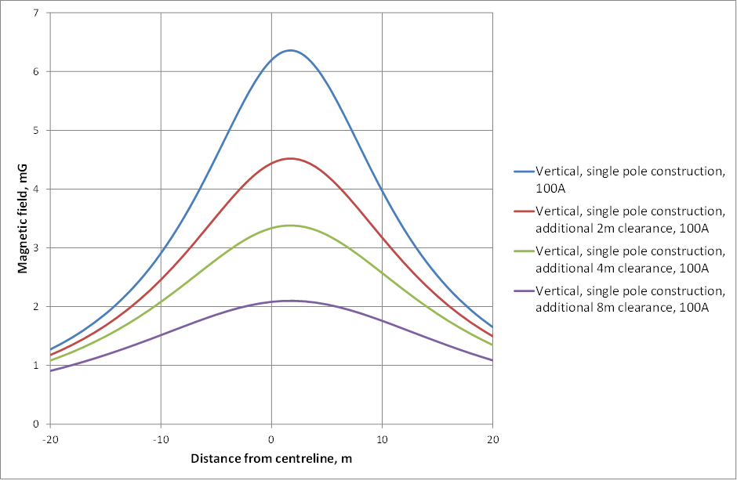
*Note: Hypothetical examples. Actual field levels will depend on specifics of the powerline.
    - Conductor spacing
The magnetic field produced by a 3-phase powerlines is a result of the vector summation of magnetic fields produced by the electric current in the conductors. As the phases of the powerline are moved closer together, there is an increased cancellation effect due to the interaction between the magnetic fields produced by each phase current.
An excellent example of this is Aerial Bundled Conductor (ABC) where the insulated cables are twisted together and strung overhead.
There is a practical limit to the reduction in spacing that can be achieved for open wire or air-insulated construction, due to flashover and reliability considerations, and in some cases, the safe approach distance for live-line maintenance work.
The effect of varying the conductor spacing is shown by comparing the magnetic field profiles from different open wire construction types (See Figure 9-1). Steel tower construction typically has conductors further from the ground, but has large phase separations, resulting in a wider profile. Delta and vertical construction have the smallest phase separation resulting in narrower and smaller profiles.
Delta construction generally produces the lowest fields at a distance from the powerline due to better cancellation effect.
Vertical construction generally produces the lowest fields directly below the powerline as it requires taller poles to maintain the minimum conductor-to-ground clearances.
Vertical construction can involve increased cost and increased visual presence (height) compared to delta construction. However, vertical construction can provide benefits where tree clearing needs to be minimised and in places where the road reserve is too narrow for delta construction.
Horizontal construction (H pole) produces higher fields than vertical or delta configurations due to all conductors being close to the ground.
Figure 9-3 Magnetic field profiles for different overhead line configurations at 1m above ground level
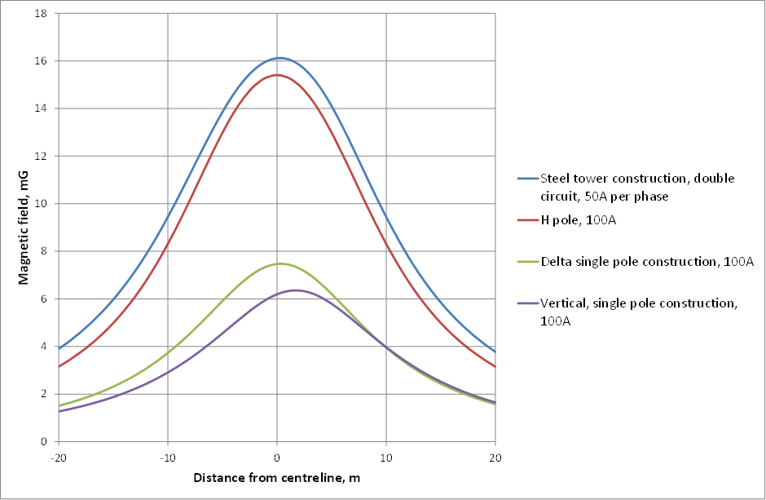
*Note: Hypothetical examples. Actual field levels will depend on specifics of the powerline.
    - Phase arrangement
For double circuit lines, it may be possible to arrange the phases to maximise the magnetic field cancellation.
A particular case of arranging the phases is the reverse phasing (low reactance) double circuit vertical configuration (See Figure 9-1). In this example, the split phase produces lower fields than having one circuit out of service.
The maximum effectiveness of this measure depends on the relative magnitude of the load current in each circuit, direction of load flow, and the relative angle shift between the circuit currents.
Figure 9-4 Effect of phasing on a double circuit line
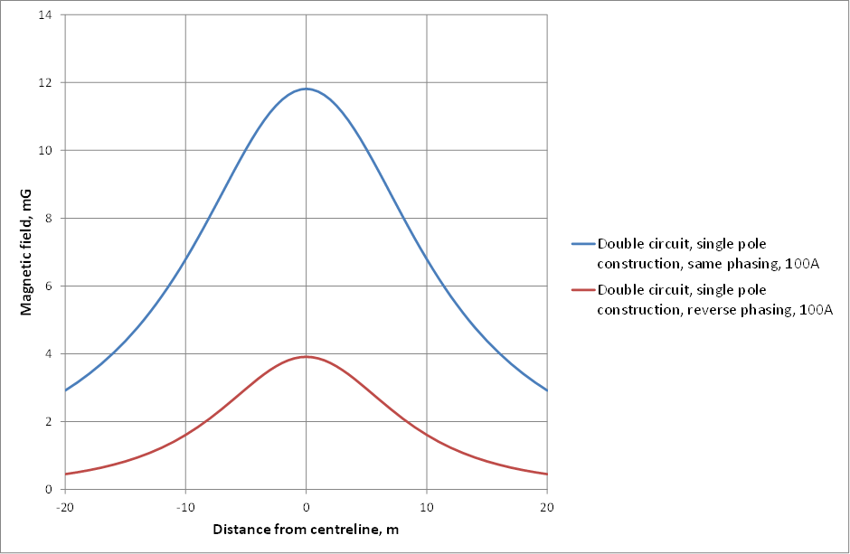
*Note: Hypothetical examples. Actual field levels will depend on specifics of the powerline.
    - Split Phasing
Another application of field cancellation through phase configuration is ‘split phasing’ where a single circuit is constructed as two parallel circuits. For maximum cancellation the conductors of one circuit are arranged in a reverse phased configuration in respect to the other circuit.
Split phasing typically has limited applications as it involves increased cost (larger poles, additional conductors, more components and in some cases wider easements) and increased physical and visual presence (i.e. height, width, potentially greater vegetation clearing, greater bulk of components and additional wires).
The effectiveness of this measure is shown in Figure 9-5.

Figure 9-5 Effect of split phasing
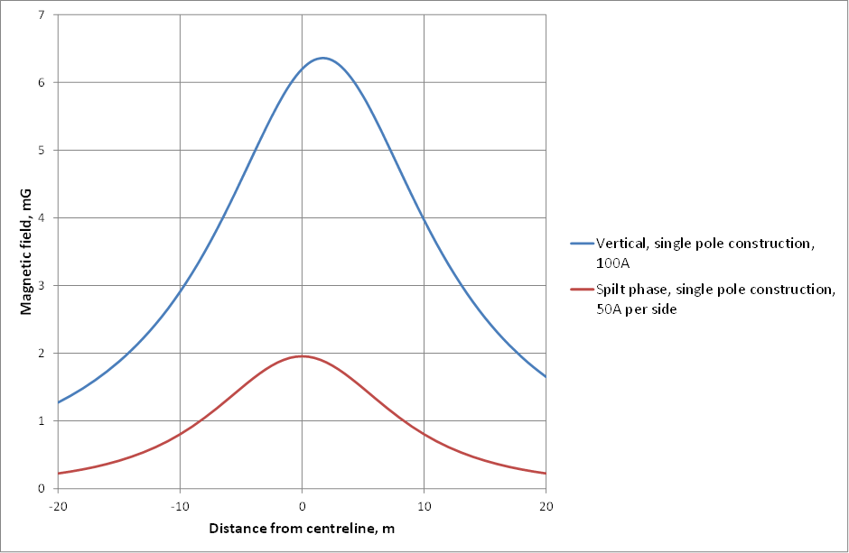
*Note: Hypothetical examples. Actual field levels will depend on specifics of the powerline.
    - Voltage, current and power
The magnetic field strength is directly proportional to the magnitude of the current flowing in the conductor. The higher the current is, the higher the magnetic field strength.
Higher voltage powerlines, which are normally used to transfer large amounts of power over large distances, can transfer the same amount of power with less current than a lower voltage powerline. As a result, for a similar power transfer, a powerline operating at a higher voltage will produce a lower magnetic field than a line operating at a lower voltage. It is a common misconception that higher voltage powerlines automatically equate to higher magnetic fields.
The choice of voltage is determined by network and other requirements.
    - Shielding
Shielding is the erection of a barrier between source and receiver to reduce the field strength at the receiver. Due to costs, it is unlikely that shielding will be consistent with a prudent avoidance approach.
For all practical purposes there are no means to shield magnetic fields from overhead lines. In special applications, shielding of areas and individual pieces of equipment is possible using structures or enclosures made from special metals, however, these are expensive and limited in application.

    - Passive and active compensation
Passive compensation is based on the principle of using induction from a powerline in parallel wires which are either earthed or connected into an elongated loop. Due to the Faraday law of electromagnetic induction, a current is induced in these wires, and flows in the opposite direction to the direction of the current in the powerline. As a result, the magnetic field produced by the induced current opposes the magnetic field produced by the powerline, resulting in a net reduction.
In practice the achievable reduction from passive compensation is limited and restricted to a particular area. It is also possible that the field will be increased elsewhere. Other factors that need consideration include line losses, the possible need for capacitors and ongoing maintenance.
Active compensation is based on the same principle as passive compensation, but its effectiveness is enhanced by boosting the magnitude of the induced current by means of a separate power supply. By controlling the magnitude and phase angle of the current from the power supply, this method of EMF mitigation can provide improved, but more expensive, magnetic field compensation.
Due to cost, safety, operation, maintenance and visual amenity issues associated with the use of passive or active loops, other than in exceptional circumstances, it is unlikely that either of these two methods of EMF mitigation would satisfy the prudent avoidance criteria.
    - Undergrounding is not consistent with prudent avoidance
Because undergrounding is usually far more expensive than overhead construction, it is normally outside the scope of prudent avoidance in the context of an overhead powerline.
On the issue of undergrounding, the Gibbs Report specifically stated that, “because of its additional cost, undergrounding solely for the purpose of avoiding a possible risk to health should not be adopted”. It should also be noted that undergrounding can result in higher magnetic fields directly above the cables.
The application of prudent avoidance for proposed underground cables is discussed in Section 9.2.
    - Distribution overhead lines
Generally, the reduction measures outlined above also apply to low voltage lines. In addition the following measures can be considered for low voltage lines to reduce the magnetic fields:
Bundle conductor configuration to significantly reduce the field profile (eg aerial bundled conductors - ABC) ABC can offer a significant reduction in the magnetic field compared to open wire construction. This is especially the case in locations on upper floors of buildings adjacent to the powerlines.
- A twisted bundled conductor will further reduce magnetic field.
- Place the neutral conductor with the phase conductors for insulated lines and cables.
- Minimise stray currents and residual currents by eliminating alternate paths for neutral current (magnetic fields from stray/residual currents decrease less rapidly than the fields from lines). Due to the use of multiple earth neutral (MEN) systems for neutral earthing, it is inevitable that some portion of the neutral current will flow through metallic water pipes and through neutrals of interconnected distributors. This will result in stray or residual current.
- Balance loads across all phases to reduce neutral currents (magnetic fields from unbalanced currents decreases less rapidly than the fields from lines with balanced currents). Unless harmonic currents are also suppressed, this measure might have limited success as some harmonic currents are returning to the source through the neutral.
- Avoid phase-by-phase grouping of single core cables in parallel circuits.
Predicting magnetic fields from low voltage lines is complicated by the fact that low voltage lines typically have unbalanced loads and a residual earth return current. Further, load from the low voltage lines decreases towards the end of the distributor as load is tapped off along its length. Typical profiles for a low voltage line, balanced, unbalanced and unbalanced with a residual current are shown in Figure 9-6.
Figure 9-6 Magnetic field profiles associated with low voltage construction
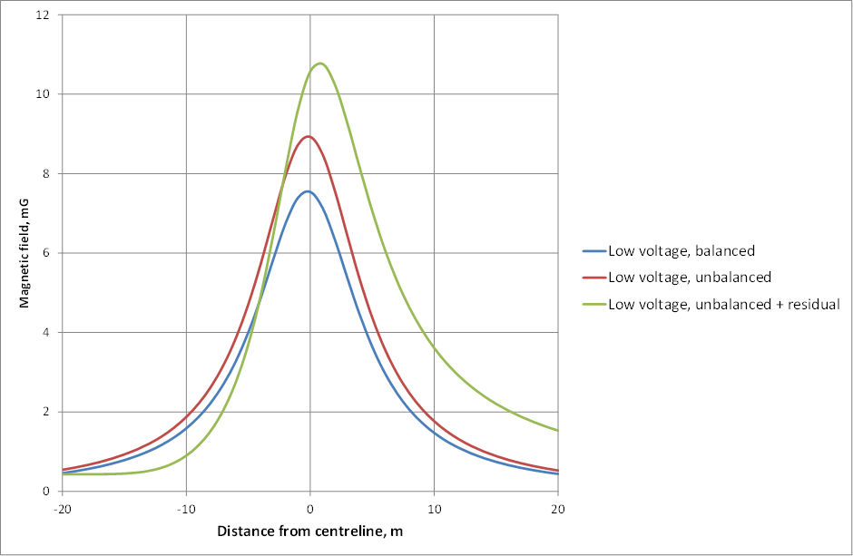
*Note: Hypothetical examples. Actual field levels will depend on specifics of the powerline.

Underground cables
The magnetic field directly above an underground cable is comparable to, and sometimes greater, than that from an equivalent overhead line. However, it drops off more rapidly with distance (See Figure 9-3 vs Figure 9-8).
In the context of prudent avoidance /precaution, the options for further field reduction are somewhat limited, but there may be some situations where additional measures can be justified.
The calculations shown in this section are indicative only and based on 132kV configurations. Phase separation, cable depths and other factors will vary depending on component suppliers and project specifics. The following construction types are referred to in the calculations.

Figure 9-7 Different underground construction configurations
 | 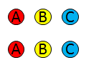 | 
Flat | Stacked double circuit, flat, same phasing | Double circuit, flat, same phasing
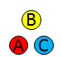 | 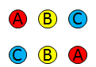 | 
Trefoil | Stacked double circuit, flat, reverse phasing | Double circuit, flat, reverse phasing
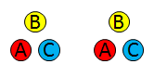 | 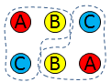 | 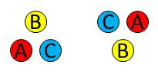
Double circuit, trefoil, same phasing | Double circuit, trefoil, reverse phasing – alternate arrangement | Double circuit, inverted trefoil, reverse phasing
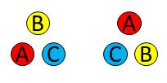
Double circuit, trefoil, reverse phasing
    - Distance
The extent of magnetic field reduction with distance from underground cables can be seen in all figures within this section. When the cable is to be installed in a roadway, consideration could be given to selecting sides of the road which are less populated, installation within the carriageway, or in some cases, alternative routes. In these cases installing the trench in the centre of the road may maximise distance to all properties, however, consideration should be given to additional cost, reinstatement and traffic impacts.
Alternative routes (unless comparable in cost) are rarely justified on EMF grounds alone given the typically low exposures and therefore limited opportunities for further material reductions.
Increasing the depth of cables may result in some field reduction directly above the cables, but generally results in a significant increase in cost and a negligible difference beyond a few metres away from the cables.
    - Voltage
See Section 9.1.5.

    - Conductor spacing
As for overhead lines, as the phases are moved closer together, there is increased phase-to-phase cancellation of the magnetic field and the total resultant field strength decreases.
This method is particularly effective for underground cables as the conductors are insulated and are therefore not limited by flashover. However, conductor spacing is limited by thermal ratings.
Options include trefoil, multicore cables and triplex (twisted three core cables).
Figure 9-8 Flat versus trefoil construction
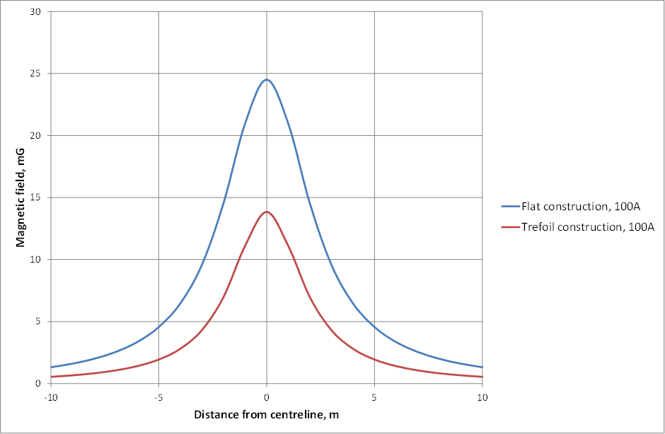
Note: Hypothetical examples. Actual field levels will depend on specifics of the powerline.
    - Phase arrangement
For double circuit lines, it may be possible to arrange the phases to maximise the magnetic field cancellation.
A particular case of arranging the phases is the inverted trefoil with reverse phasing. This arrangement can result in a significant reduction in magnetic field at a distance from the cables.
Where undergrounding involves a double circuit flat arrangement consideration could be given to phasing the circuits so that the EMF profile is lowest with both circuits operating and yet still minimal when one circuit is out of service – See Figure 9-7 (Double circuit, trefoil, reverse phasing – alternate arrangement).

Figure 9-9 Double circuit, flat construction
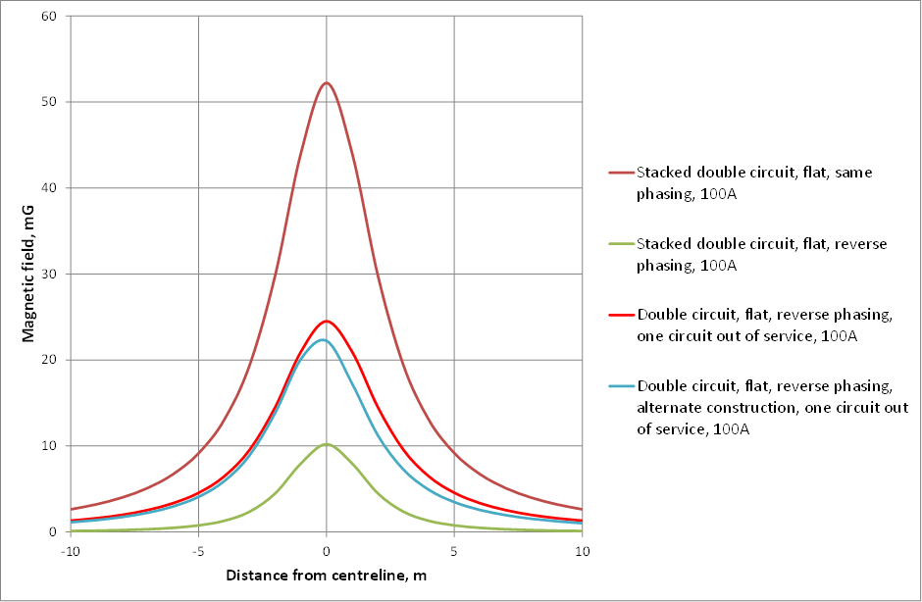
*Note: Hypothetical examples. Actual field levels will depend on specifics of the powerline.
Figure 9-10 Double circuit trefoil construction
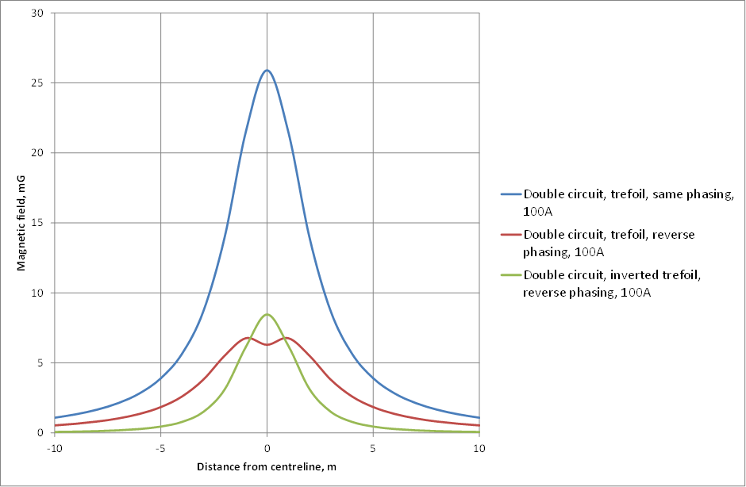
*Note: Hypothetical examples. Actual field levels will depend on specifics of the powerline.
    - Shielding
Although shielding of underground cables is theoretically possible, consideration needs to be given to de-rating of cables, access to cables after a fault, corrosion of shielding materials, cost of construction and ultimately the scope for any further field reduction, given the already compact cable arrangement. In extreme cases consideration could be given to bonding cable sheaths together at each end. However, this method is usually not possible due to de-rating effects.
Beyond a few metres, the magnetic field profile for an underground cable is usually less than for the overhead equivalent. While the magnetic field directly above the cables could be comparable or higher than for the overhead equivalent, due to the fact that cables are frequently located in roadways or footpaths, people’s exposure is generally of short duration and transient in nature. Where the cables are installed in compact trefoil and consideration is given to the route alignment, the scope for further prudent avoidance measures are generally limited.

Substations
Predicting magnetic field profiles for substations is a complex exercise given the multitude of time varying sources orientated in multiple directions. As a result, the magnetic field profile is highly dependent on the particular circumstances. The following measures are general in nature and could be further explored as part of a site specific assessment.
    - Distance
The areas of focus for magnetic field reduction are those areas accessible to the public. For substations, this location is generally the security fence line.
No cost/very low cost magnetic field reduction may be accomplished in a variety of ways, including substation siting, location and orientation of equipment, busbars and cabling, and location of access ways, buildings. Considerations include:
- Substation siting taking into consideration land use, land size, existing easements, proximity to load centre and proximity to powerline routes. While EMF should be a consideration in site selection, land availability, acquisition costs and proximity to feeders are often the dominant factors.
- Locating substations close to the load centre and existing feeders to minimise losses and the need for longer or more powerlines.
- Locating major magnetic field sources within the substation to increase separation distances. Major magnetic field sources include the transformer secondary terminations, cable runs to the switchroom, capacitors, reactors, busbars, and incoming and outgoing feeders.
- Minimising fields from incoming and outgoing powerlines.
- Locating items which produce the lowest magnetic fields closest to the boundaries (eg control rooms, equipment rooms, amenities, fire stairs, lifts, walkways, transformer roadway, oil containment, air vents/ducts and pilot isolation rooms).
- Planning the substation layout with its LV side further away from the location of interest than its HV side. (The HV side currents are substantially smaller than the LV side and, hence the HV equipment generally has a smaller associated magnetic field).
- Orienting equipment so that magnetic fields are minimised.
    - Conductor spacing and busbar arrangement
The magnetic field strength at ground level is a result of the addition of the magnetic field vectors of the various current carrying conductors. As the phases are moved closer together, there is increased phase-to-phase cancellation of the magnetic field and the total resultant field strength decreases.
Due to flashover and reliability considerations for the circuit, there is a practical limit to the reduction in spacing that can be achieved for exposed conductor construction. A reduction in conductor spacing can also impact on worker safety and could result in the need for extended planned outages to facilitate maintenance work.
For overhead busbars, horizontal or vertical configurations typically have larger phase spacing and hence produce higher fields under the busbar than triangular or delta configurations.
For underground cables/busbars a compact arrangement generally produces a lower magnetic field profile. Example considerations include:
- avoid direct ceiling/floor mounting of heavy current cables, open type busbars or disconnector switches, depending on adjoin uses
- locate cable trays away from walls/ceilings/floors depending on adjoining uses
- triangular or delta bus configurations
- compact arrangement of underground cables/busbars.
The use of compact gas insulated or vacuum switchgear as compared to open or enclosed air insulated switchgear results in significantly lower magnetic fields due to a substantial reduction in phase separation distances. A degree of shielding is also afforded by gas filled enclosures.
    - Phase configuration
The phasing relationship between all busbars and equipment in the substation will affect the magnetic field strength at any particular location.
Selective use of some phase configurations can be used as a field cancellation technique. Examples can include placing equipment back to back, grouping busbars/cables, and reverse phasing cables.
    - Voltage
While a higher voltage substation could produce lower magnetic field levels than a lower voltage substation, the choice of voltage is determined by network and other requirements.
    - Shielding
Shielding is the erection of a barrier between source and subject to reduce the field strength at the subject. Any object between the source and the point of interest will provide shielding or distortion of the electric field. Common examples are buildings, trees or any other structure.
Magnetic fields can be shielded by ferromagnetic or conductive materials. However, the available methods can be complex, costly and can have the opposite effect by concentrating magnetic fields. Shielding usually falls outside the scope of prudent avoidance.
The use of compact gas insulated or metal clad switchgear offers a degree of shielding.
In limited cases the installation of a passive shielding loop can be effective in reducing the magnetic field at a particular point. See Section 9.1.7 for additional detail on passive shielding.

Low voltage distribution substations
The measures described above also generally apply to low voltage substations. In addition the following measures could be considered:
- Design busbars to minimise separation between phases and the neutral bus.
- Use multicore or trefoil cables in preference to three single phase cables.
- Minimise stray currents and residual currents by eliminating alternate paths for neutral current (magnetic fields from stray/residual currents decreases less rapidly than the fields from lines) Due to the multiple earth neutral (MEN) systems of the neutral earthing, it is inevitable that some portion of the neutral current will flow through metallic water pipes and through neutrals of interconnected distributors. This will result in stray or residual current.
- Balance loads across all phases to reduce neutral currents (magnetic fields from unbalanced currents decrease less with distance than the fields from lines with balanced currents).
- Avoid phase-by-phase grouping of single core cables in parallel circuits.
- Orientate the LV end of the substation furthest from the receiver.
- Install and appropriately group the LV cables between transformers and switchboard and consumer mains cables.

FURTHER INFORMATION
CIGRE - 2009 - TB 373 Mitigation Techniques Of Power-Frequency Magnetic Fields Originated From Electric Power Systems. See more at www.e-cigre.org/
ENA ER G92 Issue 1 - Guidelines for Best Practice in relation to Electric and Magnetic Fields (EMFs) in the Design and Management of Low Voltage Distribution Networks. See more at www.energynetworks.org

MEDICAL IMPLANTS
There are many types of implanted cardiac pacemakers and other medical implants and in some circumstances these devices may be susceptible to interference from external fields, including radio-frequency fields and power-frequency EMF.
While there are many different manufacturers and models of pacemakers, more recently manufactured devices tend to be designed to shield against external influences. Many pacemakers are designed to 'fail safe' by reverting to fixed-rate operation when they sense the presence of interference above a certain level. The field strengths necessary to induce such behaviour vary from one pacemaker model to another.
Generally, standards place an obligation on designers and manufacturers of medical implants to make them immune to interference in up to the public Reference Levels as set by ICNIRP. One such example is CENELEC, the European electrical standards organisation, BS EN 45502 - Active implantable medical devices. As regulations, standards and devices vary depending on the manufacturer and country of origin and distribution, advice should always be sought from the manufacturer or medical professional.
The following are examples of medical implants that may be susceptible to electromagnetic interference:
- cardiac pacemakers and defibrillators
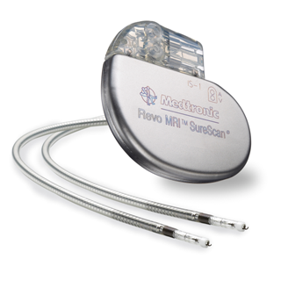
- leads associated with devices such as pacemakers
- insulin or other drug infusion pumps
- continual glucose monitoring
- spinal cord stimulators (for back pain)
- cochlear implants
- neurostimulators (e.g. for epilepsy, parkinsonism or incontinence).
As the susceptibility of medical implants to EMF interference can differ, there is a need for a case-by-case risk management approach in consultation with the wearer’s treating physician.

Medical implant risk management
For occupational exposure, a risk management approach needs to be adopted, by implementing procedures to identify workers at risk due to fitment of medical implants, and characterising their EMF exposure from the electrical network. Once identified, an assessment can be conducted in consultation with the recipient’s doctor to manage the occupational exposure to EMF of workers with medical implants and ensure that exposures are less than those which may interfere with the implant’s normal operation.
Control measures can be implemented, advising the worker of any necessary restrictions or changes of their work practices to protect them from unwanted EMF exposure. Risk assessments need to be conducted on a case-by-case basis to determine the likely susceptibility of medical implants whilst performing particular tasks and the severity of the consequences should the medical implants fail or experience interference.
As part of the pre-employment induction process for working on an electrical network, raising awareness of the risk and a confidential check for medical implants should be completed to identify those persons who might have medical implants.
Workers fitted with medical implants should discuss their work and working environment with their doctor and provide the network business with a letter from their doctor describing the circumstances in which the proper functioning of the medical implant or implant may be at risk.
Having involved parties informed will allow for a risk management approach to be adopted that assesses the individual’s circumstances so that an effective safety management strategy can be developed.
For general public exposure risk assessment requirements, the recipient should be referred to their treating physician and manufacturer and advice provided on typical exposures.
FURTHER INFORMATION
Refer to medical implant manufacturer.

SIGNAGE
Signage although discretionary, may be used as one means of controlling exposure situations where there is risk of micro shocks interference to medical implants (See Section 10), and areas where levels could exceed the Reference Levels. It should be noted that signage is only one tool to manage such risks and that many of these risks can be effectively managed by other means such as engineering and administrative controls.
Generally, signage is not considered to be a practical prudent avoidance measure for utilities, given the ubiquitous nature of electricity distribution and usage.
Signage where deemed appropriate, should generally meet the requirements of Standard AS1319 – 1994 Safety Signs for the Occupational Environment which has a category for “Warning” signs. Some examples of signage wording are shown in Figures 12-1 to 12-3. However, the actual wording chosen needs to have regard to the nature of the area to which the sign applies and the management controls in place.
Figure 11-1 Example wording for signage where electric or magnetic field levels may cause interference to medical implants (see Section 10)
WARNING
MEDICAL IMPLANTS
ELECTRIC AND MAGNETIC FIELDS MAY INTERFERE WITH IMPLANTS
SEEK MEDICAL ADVICE BEFORE ENTERING
Figure 11-2 Example of signage where electric or magnetic field levels may exceed Reference Levels
WARNING
HIGH MAGNETIC FIELD AREA
NO UNAUTHORISED ENTRY

WARNING
ELEVATED ELECTRIC FIELDS IN THIS AREA MAY CAUSE MINOR SHOCKS SIMILAR TO STATIC ELECTRICITY
THIS MAY BE NOTICEABLE FOR SOME PEOPLE
FOR FURTHER INFORMATION CALL …

EMF COMMUNICATION
Communication and sharing of information with the community is a key element of EMF management for utilities. A number of relevant principles and ideas are set out below:
- When EMF issues arise, respond promptly and thoughtfully.
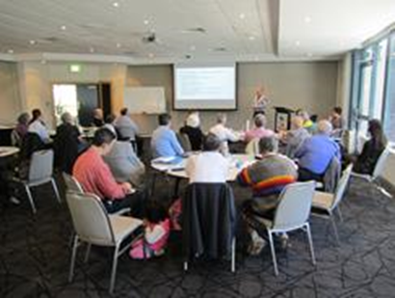
- Have available EMF materials such as a policy position and factsheets:
- ENAs brochure Electric and Magnetic Fields – What we know
- ENA EMF Policy Statement
- ARPANSA Facts Sheets
- WHO Fact Sheet
- Keep EMF materials accurate, current and consistent.
- Align messages with ARPANSA’s public position. This alignment will provide a sound basis positions and practices.
- Consider an EMF measurement program as a means of responding to customer inquiries. Ensure that the measurements are reported in their context, consistent with advice from ARPANSA. Providers of reading material should be both knowledgeable of the consensus science and approachable. Details of the preferred measurement technique and instrumentation for making time-averaged measurements are available in a measurement protocol developed by ARPANSA.
- Think about the levels of response in your organisation. Ensure that all staff that interface with the public understand the nature of public concern, have credible EMF materials available and are familiar with them.
- Maintain a role within the company that keeps abreast of the health science, the policy position of regulators and best practices and can support the front line staff when required. The person in this key communication role should be able to address any deeper concerns with credibility and understanding.
- Seek assistance from the ENA EMF Reference Group.

MORE INFORMATION
ARPANSA 2002 - Measurement of Residential Power Frequency Fields. See www.arpansa.gov.au
WHO – 2002 - Establishing a Dialogue on Risks from Electromagnetic Fields. See more at www.who.int
IAP2 Public Participation Spectrum. See more at www.iap2.org.au

REFERENCES
Anderson, V, 2009, B field compliance for 50 Hz live line work, Swinburne University, 2 September 2009
Australian Standard AS1319 – 1994 Safety Signs for the Occupational Environment
ARPANSA Fact Sheet – Electricity and Health March 2015
Bracken, TD, and Dawson, T, 2004, Evaluation of Non- uniform 60 Hz Magnetic-Field Exposures for Compliance with Guidelines, J Occ Envir Hyg, 1, 629 – 638
BS EN 50499:2008 – Procedure for the assessment of the exposure of workers to electromagnetic fields
CIGRE 2009b, Mitigation techniques of Power-frequency Magnetic Fields Originated from Electric Power Systems No 373, Working Group C4.204 February 2009
Dawson, TW, Caputa, K and Stuchley, MA, 1999, Numerical evaluation of 60 Hz magnetic induction in the human body in complex occupational environments. Phys Med Biol, 44, 1025-1040
Dawson, TW, Caputa, K and Stuchley, MA, 2002, Magnetic field exposures for UK live-line workers. Phys Med Biol, 47, 995-1012
Dimbylow, P and Findlay, R, 2009, The effects of body posture, anatomy, age and pregnancy on the calculation of induced current densities at 50 Hz, Rad Prot Dos, advanced access published 23 December 2009
Dimbylow, P, 2005, Development of pregnant female voxel phantom, NAOMI< and its application to calculations of induced current densities and electric fields from applied low frequency magnetic and electric fields, Phys Med Biol 50 1047-1070
Dimbylow, P, 2006, Development of pregnant female, hybrid voxel-mathematical models and their application to the dosimetry of applied magnetic and electric fields at 50Hz. Phys Med Biol 51, 2383-2394
ENA, 2014, Policy Statement on Electric and Magnetic Fields (EMF).
ENA, 2014, “Electric and Magnetic Fields – What We Know”.
ENA ER G92 Issue 1 - Guidelines for Best Practice in relation to Electric and Magnetic Fields (EMFs) in the Design and Management of Low Voltage Distribution Networks
ENA UK, 2012, Power Lines: Demonstrating compliance with EMF public exposure guidelines-A Voluntary Code of Practice, March 2012
Gibbs, Sir Harry (1991). Inquiry into community needs and high voltage transmission line development. Report to the NSW Minister for Minerals and Energy. Sydney, NSW: Department of Minerals and Energy, February 1991.
IARC, 2002, Non-Ionizing Radiation, Part 1: Static and Extremely Low-Frequency (ELF) Electric and Magnetic Fields
ICNIRP, 1998, Guidelines for limiting exposure to time varying electric, magnetic fields and electromagnetic fields (up to 300GHz) Health Physics 1998, 74, 494 – 522.
ICNIRP, 2010, Guidelines for limiting exposure to time varying electric and magnetic fields (1Hz to 100 kHz) Health Physics December 2010, 99, 818 – 836.
ICNIRP, 2010, Guidelines for Limiting Exposure to Time-Varying Electric and Magnetic Fields (1 Hz - 100 kHz)
IEC 62226-2-1, Exposure to electric and magnetic fields in the low to intermediate frequency range-Methods for calculating current density and internal electric fields in the human body. Part 2-1 Exposure to magnetic fields - 2D models.
IEC 61786, Measurement of low frequency magnetic and electric fields with regard to exposure to human beings – special requirements for instruments and guidance for measurements.
IEC 62110 Electric and magnetic field levels generated by AC power systems - Measurement procedures with regard to public exposure.
IEC 62311, Assessment of electronic and electrical equipment related to human exposure for electromagnetic fields (0-300Ghz)
IEEE, 2002, Standard C95.6 IEEE Standard for Safety levels with respect to Human Exposure to Electromagnetic Fields 0-3kHz, 22 October 2002
IEEE, 2010, IEEE Recommended Practice for Measurements and Computations of Electric, Magnetic, and Electromagnetic Fields with Respect to Human Exposure to Such Fields, 0 Hz to 100 kHz
Karipidis, K, 2002, Measurement of Residential Power Frequency Fields
National Radiological Protection Board, 2004, Review of the Scientific Evidence for Limiting Exposure to Electromagnetic Fields (0-300 GHz)
National Institute of Environmental Health Sciences U.S. 1999, National Institutes of Health - Health Effects from Exposure to Power-Line Frequency Electric and Magnetic Fields
New Zealand Ministry of Health, 2008, information booklet “Electric and Magnetic Fields and Your Health”
Peach H.G., Bonwick W.J. and Wyse T. (1992). Report of the Panel on Electromagnetic Fields and Health to the Victorian Government (Peach Panel Report). Melbourne, Victoria: September, 1992. 2 volumes: Report; Appendices.
Repacholi M, “Concern that ‘EMF’ magnetic fields from power lines cause cancer.” Sci Total Environ (2012), doi:10.1016/j.scitotenv.2012.03.030, page 3. [citing PubMed]
SCENIHR (Scientific Committee on Emerging and Newly Identified Health Risks). Opinion on Potential health effects of exposure to electromagnetic fields (EMF) 2015
UK Department of Energy and Climate Change - 2012 - Power Lines: Demonstrating compliance with EMF public exposure guidelines - A voluntary Code of Practice
WHO 2007, Extremely Low Frequency Fields – Environmental Health Criteria, Monograph No. 238 March 2007
WHO 2007, Electromagnetic fields and public health – Exposure to extremely low frequency fields. Fact Sheet 322 of June 2007
Wood, AW, 2008, Extremely low frequency (ELF) Electric and Magnetic Fields Exposure Limits: Rationale for Basic Restrictions used in the Development of an Australian Standard. Bioelectromagnetics 2008, 1-15

GLOSSARY

Definitions
Basic Restrictions
Limitations on the quantities that most closely match all known biophysical interaction mechanisms with tissue (source ICNIRP 2010). (measured in V/m).
Distribution voltages
Voltages less than or equal to 33kV
Electric and Magnetic Fields, (EMF) – (Sometimes referred to as electromagnetic fields)
Power frequency electric and/or magnetic fields in the environment. At this frequency, the electric and magnetic components are independent of one another. EMF should not be confused with ‘electromagnetic radiation’ (see below). Electric fields are measured in volts/metre (V/m). Magnetic Fields are measured in gauss (G) or tesla (T).
Electromagnetic Radiation
Electromagnetic radiation is a term used to describe the movement of electromagnetic energy through the propagation of a wave. This wave, which moves at the speed of light, is composed of electric and magnetic waves which oscillate (vibrate) in phase with, and perpendicular to, each other. This is in contrast to EMF, where the electric and magnetic components are essentially independent of one another.
ELF or Extremely Low Frequency
A frequency in the range 0 to 3000 Hz.
Exposure
The circumstance of being in the immediate presence of ELF electric or magnetic fields, or having such fields cause electric currents to flow through the body or within the body.
Gauss (G)
A measure of magnetic flux density (also sometimes called magnetic field strength). It may appear on meters to measure magnetic field (gauss or milligauss). One gauss = 10-4 tesla, the SI unit for magnetic flux density. It is often convenient to use milligauss (mG) for EMF communication as most fields encountered in practice are on a scale of 1 to 1000, thereby obviating the need for small fractions.
Magnetic field
In this document the term ‘magnetic field’ is equivalent to ‘magnetic flux density’ (refer below).
Magnetic flux density (B)
A vector quantity that determines the force on a moving charge or charges (that is, on an electric current) within a magnetic field. Magnetic flux density is expressed in teslas (T). One gauss (deprecated unit) equals 10-4 T. The quantity commonly referred to in non-technical uses as magnetic field strength.
Magnetophosphenes
The sensation of flashes of light caused by induced electric currents stimulating the retina.
Micro-shock
A micro-shock is a sensation caused by a small electric spark discharge or arc occurring when a person, isolated from ground and exposed to a high electric field, approaches within a few millimetres of an earthed object. Alternatively, a person in contact with ground may experience a micro-shock when approaching an isolated charged conductor. Micro-shocks are due to the transfer of induced charge from the isolated to the grounded object.
Non-uniform field
A field that is not constant in amplitude, direction and relative phase over the dimensions of the body or body part under consideration. In the case of electric fields, the definition applies to an environmental field disturbed by the presence of the body.
Occupational exposure - ICNIRP
See Section 5.2.
Occupational exposure - IEEE
See Section 5.2.
Public exposure (also general public exposure)
Exposure that is not classified as occupational exposure.
Reference Levels
The rms and peak electric or magnetic fields and contact currents to which a person may be exposed without an adverse health effect and with acceptable safety factors. The Reference Levels for electric and magnetic fields in this document may be exceeded if it can be demonstrated that the Basic Restrictions are not exceeded. Thus it is a practical or “surrogate” parameter(s) that may be used for determining compliance with the Basic Restrictions (source ICNIRP 2010).
Safety factor
A factor used in deriving Basic Restrictions and Reference Levels that provides for the protection of exceptionally sensitive individuals, uncertainties concerning threshold effects due to pathological conditions or drug treatment, uncertainties in reaction thresholds, and uncertainties in induction models.
Tesla (T)
SI unit of magnetic flux density (also sometimes called magnetic field strength). One gauss = 10-4 tesla.
Transmission voltages
Voltages greater than 33kV
Uniform field
A field that is constant in amplitude, direction and relative phase over the dimensions of the body or body part under consideration. In the case of electric fields, the definition applies to an environmental field undisturbed by the presence of a body.

Acronyms and abbreviations
ABC | Aerial Bundled Conductor
ARPANSA | Australian Radiation Protection and Nuclear Safety Agency
BS | British Standard
CENELEC | European Committee for Electrotechnical Standardization
CIGRE | Council on Large Electric Systems
DC | Direct Current
ELF | Extremely low frequency
EMR | Electromagnetic Radiation
EMF | Electric and Magnetic Fields
ENA | Energy Networks Association
EPRI | Electric Power Research Institute
EU | European Union
G | Gauss
HV | High Voltage
IARC | International Agency for Research on Cancer
ICNIRP | International Commission on Non-Ionizing Radiation Protection
IEEE | Institute of Electrical and Electronics Engineers (of USA)
IMD | Implanted Medical Device
kV | kilovolts
LV | Low Voltage
M | Milli (x10-3)
MEN | Multiple Earth Neutral
NIESH | US National Institute of Health Sciences
NRPB | UK National Radiation Protection Board
RF | Radio Frequency
SCENIR | Scientific Committee on Emerging and Newly Identified Health Risks
RMS | Root-mean-square
T | Tesla
TWA | Time Weighted Average
u | Micro (x10-6)
V | Volts
WHO | World Health Organization

APPENDIX 1 Magnetic field mitigation checklist
The following checklist summarises the magnetic field reduction measures discussed in Section 9.
OVERHEAD POWERLINES
The following measures may reduce magnetic field exposure depending on the project. Whether they fall within the meaning of prudent avoidance/ precaution will depend on the specific circumstances (see Section 8). All measures will need careful consideration of cost, effectiveness and other project objectives.
- Minimise loads by optimising network configuration
- Install on sides of the road which are less populated
- Consider alternate routes
- Utilise existing easements
- Raise the height of supporting structures
- Use a compact phase configuration (vertical or delta construction)
- Reverse phase of dual circuit lines
- Increase the balancing of loads on dual circuit feeders
- Split phase sections of single circuit line
- Use highest practicable voltage
Further measures for distribution voltages:
- Bundle conductors (eg ABC)
- Minimise stray currents and residual currents
- Balance loads across all phases to reduce neutral currents
- Avoid phase-by-phase grouping of single core cables in parallel circuits
UNDERGROUND CABLES
The following measures may reduce magnetic field exposure depending on the project. Whether they fall within the meaning of prudent avoidance /precaution will depend on the specific circumstances (see Section. All measures will need careful consideration of cost, effectiveness and other project objectives.
- Minimise loads by optimising network configuration
- Install cables within the roadway (transmission) or on sides of the road which are less populated
- Utilise existing easements
- Use compact trefoil arrangement of single core cables
- Optimally arrange and phase of dual circuits (eg reverse phasing and inverted trefoil)
- Where a dual circuit flat arrangement is used, optimally phase dual circuits to allow for compact arrangement when one feeder is out of service
- Increase the balancing of loads on dual circuit feeders
- Where there are transitions from trefoil to flat, change phasing to maintain optimum phasing
- Use highest practicable voltage

Further measures for distribution voltages:
- Use multicore cables or trefoil single core cable
- Place neutral conductors with the associated phase conductors
- Minimise stray currents and residual currents
- Balance loads across all phases to reduce neutral currents
- Avoid phase-by-phase grouping of single core cables in parallel circuits
SUBSTATIONS
The following measures may reduce magnetic field exposure depending on the project. Whether they fall within the meaning of prudent avoidance will depend on the specific circumstances (see Section 8). All measures will need careful consideration of cost, effectiveness and other project objectives.
- Minimise loads by optimising network configuration
- Consider alternate sites
- Site substation close to load centre
- Site substation close to line routes
- Locate key magnetic field sources within the substation, to increase separation distances as far as practicable. Key magnetic field sources include the transformers and associated connections, cable runs to the switchroom, capacitors, reactors, busbars, and incoming and outgoing feeders.
- Minimise fields from incoming and outgoing powerlines.
- Locate areas with the lowest magnetic fields (eg control rooms, equipment rooms, amenities, fire stairs, lifts, walkways, air vents/ducts and pilot isolation rooms) closest to the location of interest.
- Plan the substation layout with its LV side further away from the location of interest than its HV side.
- Orientate equipment with uneven field patterns so that the highest field side is turned away from sensitive the location of interest (the LV side usually has the highest fields).
- Avoid direct ceiling/floor mounting of heavy current cables, open type busbars or disconnector switches, depending on adjoining uses
- Locate cable trays away from walls/ceilings/floors depending on adjoining uses
- Use triangular or delta bus configurations
- Use compact arrangement of underground cables/busbars and secondary connections
- Use of compact gas insulated or vacuum switchgear
- Use selective use of phase configurations as a field cancellation technique (eg back to back, grouping busbars/cables, and reverse phasing cables)
- Use highest practicable voltage
Further measures for distribution voltages:
- Design busbars to minimise separation between phases and the neutral bus
- Use multicore or trefoil cables in preference to three single phase cables
- Minimise stray currents and residual currents
- Balance loads across all phases to reduce neutral currents
- Avoid phase-by-phase grouping of single core cables in parallel circuits

APPENDIX 2 Worked examples of prudent avoidance
Double circuit underground transmission line
A 10km 132kV underground double circuit feeder was proposed to connect two substations. The cables were to be installed within the roadway and run through predominately residential areas.
No cost/very low cost measures such as trefoil and optimising the phasing were shown to be able to reduce the field levels by around 50% at the nearest habitable rooms (compared to standard flat formation). The predicted ultimate TWA magnetic field at the nearest habitable rooms was in most cases was between 3-4mG.
Despite the low magnetic field levels compared to an equivalent overhead line, some members of the community raised concerns and in response to these concerns, measures were investigated to further reduce the magnetic fields.
A further no cost/very low cost measure included changing switching points on the downstream network to improve the balancing of the feeders. This increased the overall reduction to around 70%.
Inverting one of the trefoils was shown to increase the overall reduction to around 85% (See Figure 9-7). This measure was investigated from a ratings and constructability viewpoint and found to be feasible for this project. Implementing this measure would incur an additional cost for a new mould to hold the inverted trefoil.
A number of alternative routes were also evaluated. These were considered to unduly compromise other issues in the context of this project because of additional environmental impacts, construction risk and cost. All other proposed measures were adopted.
In all, the proposed measures would achieve an overall reduction around 85% at the nearest habitable rooms. The cost for new mould was a very low one off cost and could be used for future projects,
New overhead 132kV powerline
A 10km, 132kV overhead line was proposed to connect two substations, traversing predominately residential areas. A compact delta construction was proposed for the length of the route.
The predicted ultimate TWA magnetic field at the nearest habitable rooms under ultimate loading conditions at the property boundaries in most cases was around 20mG. This decreased to around 10mG for most of the 100 residential buildings involved.
Undergrounding would reduce the magnetic field at the nearest residential buildings by around 85%, but the cost to underground was estimated to be an extra $12M (or 600%). This was clearly outside the scope of prudent avoidance.
A number of magnetic field reduction options such as spilt phasing and raising the height of the conductors with larger poles were put to the community. However, given the additional visual and amenity issues there was a strong community resistance to these measures.
An alternative route through bushland was considered, but it involved additional construction risk, environmental impacts, planning approval risk and an additional cost of $1M. For these reasons this route was considered to be outside the scope of prudent avoidance.
The only very low cost alternative routing for the powerline involved one short section which passed 10 houses. The additional cost for rerouting this section through a disused easement was $20k. Considering the project objectives, a decision was made to reroute this section.
New double circuit overhead 132kV powerline
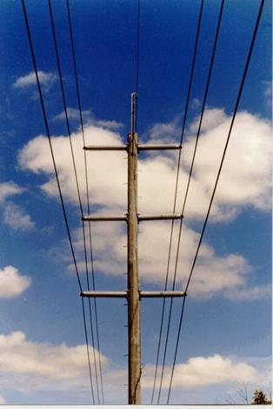
A double circuit 7km 132kV overhead line was proposed to connect two substations. Initially only one circuit would be required with the second circuit required in 7 years based on current projections. The route was chosen after extensive community consultation and was considered the most appropriate taking into account all project objectives. The circuits would ultimately be reversed phased as a very low cost means of reducing the magnetic field.
The predicted ultimate TWA magnetic field at the nearest habitable rooms was around 5mG. Without the reverse phasing this figure would be around 18mG. With only one circuit operational (as would be the case for the first 7 years), the predicted magnetic field would be around 10mG for the first 7 years.
A decision was made to adopt spilt phasing of the line for the first 7 years of operation (see Section 9.1.4). The cost of this measure was considered low in the context of the project and would result in a magnetic field reduction of around 80% for the first 7 years of operation.
New zone substation
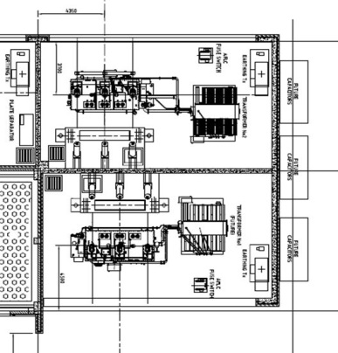
A new zone substation was proposed in a residential area adjoining two residential properties. The key sources of magnetic fields within the substation were the transformers’ secondary connections, cable runs, and capacitor banks. The predicted ultimate TWA magnetic field at the nearest habitable rooms ranged from 3 to 25mG.
A number of measures were investigated to reduce the magnetic fields from the substation.
Placing the transformers back to back, thereby enabling the fields from the secondary cable risers to in part cancel each other out. The unique nature of the site involving two transformer runways enabled this measure to be undertaken at very low cost.
The cable runs from the transformers to the switchroom were redesigned to group the cables in trefoil and use an optimum phasing arrangement.
The site layout was also redesigned to site the capacitor banks further away from habitable areas.
In all the proposed measures would achieve an overall reduction in excess of 50% at the substation boundary and over 60% at the nearest habitable area. The proposed measures were considered to be very low cost in the context of the project, had some technical advantages and took into account the concerns of the neighbouring residents.
Existing distribution line
The conductors from an existing overhead powerline are approximately 3 metres from a residential apartment. The measured fields range from 20-50mG at the part of the apartment nearest to the powerline, decreasing to 10-30mG at the centre of the nearest habitable rooms. The family of three has enquired about reducing the fields from the powerline.
To underground the line past the residence would cost around $40,000, given the current network configuration and work required. Bundling of the conductors would cost around $10,000, again given the current network configuration and work required.
Both of these reduction measures are outside the scope of ‘very low cost’ and hence could not be justified.
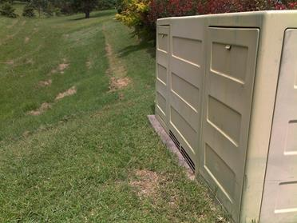
However, this case was unusual as it was noted that the fields are generally decreasing from the line at a rate of 1/d as opposed to 1/d2. This suggested that there was a high residual current in the line. Further testing revealed a loose neutral connection which was subsequently tightened. Testing showed that the field levels in the nearest habitable rooms had approximately halved.
New distribution substation
A new padmount substation was required in a residential area. There were a number of potential sites available to site the substation.
While not in the initially preferred location, a site was found away from residential buildings within a park. Given the low marginal cost, the negligible impact on technical requirements, and community preferences, a decision was made to site the substation within the park.
No magnetic field calculations were undertaken.
New chamber substation
At the request of a developer, a new chamber substation was proposed for a commercial development. An office area was located directly above the substation.
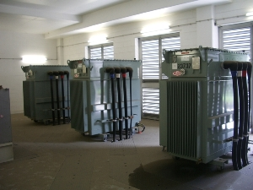
The predicted ultimate TWA magnetic field levels in the office area were generally in the range of 20-25mG. One workstation had field levels of 80-100mG as it was directly above the LV board. Being a new substation it was considered prudent to relocate and trefoil the medium voltage and low voltage cables away from the area directly below the office. This resulted in reducing the magnetic fields to 5-10 mG for all but one workstation. The developer chose the site for the substation and there were no very low cost alternative sites. It was also not practical to move the location for the LV board. The developer made a commercial decision to install Mu Metal shielding under the carpet of this workstation to reduce the magnetic fields to around 10 mG.

Proposed development near an existing transmission line
A developer was proposing a new child care centre next to a transmission line. The field levels throughout the property typically ranged from 15-25mG throughout the day, decreasing with distance from the line to an average of 2-6mG at the furthest point on the property from the line. As the developer was not proposing to encroach onto the easement, the local council was the sole approving authority.
In early discussions, the council advised that they would want to see a consideration of prudent avoidance measures. They clarified that this meant a consideration of very low cost practical measures that could be implemented to reduce exposure for those who would spend most time at the centre.
As the development was in the early stages of design, a number of alternative layouts were still open for consideration by the developer. A layout was chosen which had the carpark located closest to the line followed by the entry, storage areas and toilets. The sleeping and play areas were located furthest from the line.
As the development was in the early stages and given the nature of the site, the overall cost to the developer of these measures were minimal.
The council was satisfied that there was an appropriate application of prudent avoidance /precaution and approved the development.

APPENDIX 3 EMF measurement considerations
The following sections provide additional guidance for measuring electric and magnetic fields.
A3.1 Electric Field measurement considerations
Because electric fields are shielded by most objects, other than in flat open areas, they are rarely uniform. Accordingly, the context of the measurements needs to be understood and care needs to be taken in extrapolating from one situation to another.
Electric field measurement instruments in most cases are single-axis. The electric field adjacent to a conducting surface is normal to the surface, Therefore, the horizontal component of the electric field, particularly where it is generated by overhead lines, can be ignored close to the ground surface. Single-axis measurement (vertical component) is therefore sufficient near the ground.
Particular care must be taken in the presence of conducting objects or when the clearance of the conductor from the ground is small.
To reduce perturbation of a measured electric field as a result of the operator, the distance between the electric field measurement instrument and the operator should be at least 1.5 m and 3 m is recommended.
In order to take electric field level measurements representing the unperturbed field at a given location, the area should be free as far as possible from other powerlines, towers, trees, fences, tall grass, or other irregularities. It is preferred that the location should be relatively flat. It should be noted that the influence of vegetation on the electric field level can be significant. In general, field enhancement occurs above individual items of vegetation and field attenuation occurs near the sides. Field perturbation can depend markedly on the water content in the vegetation.
Electric field measurement may also be perturbed if the relative humidity is more than 70 % due to condensation effect on the probe and support. The ability of the field meter to work correctly under those conditions should be checked before measurement.
A3.2 Magnetic field measurement considerations
When taking magnetic field measurements, it must be remembered that they represent a point in time. At other times, the magnetic field in a particular area could be higher or lower than recorded in a single set of measurements. When measuring the fields associated with a utility asset, knowledge of the source(s), phasing and currents at the time of the measurements will assist in understanding the fields under other conditions.
In most cases it is preferable to undertake magnetic field measurements with a three-axis meter which calculates the resultant field. If a single-axis instrument is used, the following equation can be used to determine the resultant field (provided that the field level remains stable during the time taken to perform the measurements).
Resultant field = (X²+Y²+Z²)^{1/2}
A single-axis instrument can be used to determine the direction of the field or undertake more detailed investigations as may be required for hidden sources. A single axis meter could also be used where the direction of the field is known and value of the semi-minor axis of the field ellipse is significantly smaller than that of the semi-major axis (such as a single current source or a 3-phase line where the line to ground distance is much larger than the phase-to-phase distance).

The following principles may be helpful when undertaking investigations:
- The magnetic field lines for straight line sources will always lie in a vertical plane perpendicular to the line (X Y plane). There will be no Z component.
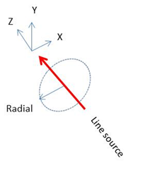
- The magnetic field direction for a single phase line source will be perpendicular to the radial.
- The magnetic field direction for a horizontal 3ph line will be predominantly vertical under the line and perpendicular to the radial at a distance.
- The magnetic field direction for a vertical 3ph line will be predominantly horizontal under the line and on the radial at a distance.
- The magnetic field direction for a delta 3ph line will approach circular polarisation at a distance and still be highly elliptical under the line.
- The magnetic field direction for a vertical double circuit line (same phasing) will be predominantly horizontal under the line. This may not hold true if the circuits have significant phase shift current between each other.
- The magnetic field direction for a vertical double circuit line (transposed phasing) will be predominantly vertical under the line. This may not hold true if the circuits have significant phase shift current between each other.
- The magnetic field from a single conductor will decrease with the inverse of the distance from source.
- The magnetic field from a three phase line with residual current (i.e. three phases and neutral net balance is not zero) at a distance from the source will decrease with the inverse of the distance from source.
When undertaking measurements the meter should be within calibration. Further, where fields are highly non-uniform, have high harmonics or are changing rapidly, there should be an understanding of the meters sampling frequency, frequency response, sensor size and sensor location.

APPENDIX 4 Electrical Loading
The electrical load and therefore the magnetic field on any powerline or substation (and some appliances) varies continually with time. Figure 14-1 shows a sample of average residential electricity load profiles for different times of the day and year. An example of an annual load duration curve for a feeder is shown in Figure 14-2.
The situation is further complicated for distribution lines as load is usually progressively tapped off along the line, the loads are typically not balanced between phases and there is often a residual earth return current (see Section 9.1.9)
In addition, changes in load growth patterns or system requirements may alter future load flows on any line in the network. An example of load forecasts for a feeder is shown in Figure 14-3.
This means that any reference to a magnetic field level needs to make some assumptions regarding the conditions under which this value occurs.
Figure 3-5 shows different loading conditions for a powerline.
For compliance assessments against the exposure limits, the load of interest is typically the short term emergency rating. See section 6.3.
For prudent avoidance assessments, the most relevant load is the Time Weighted Average (TWA). See section 8.1.
Figure 14 -1 Typical residential daily load profiles
50
* Sourced from Ausgrid’s Solar home electricity data - 1 July 2010 to 30 June 2011 (300 households)
Figure 14-2 Example annual load duration curve for a 132kV feeder
50
Figure 14-3 Example load forecast for a new overhead 33kV feeder
50

Figure 14-4 Example magnetic field profiles for a powerline under different loading conditions
50
Short Time Emergency Load – Typically used when assessment compliance against the guidelines (see Section 6). This load could be the short time thermal limit and may in practice never be reached on a line.
Infrequent High Load – The yearly peak with the system substantially normal.
Typical Daily Maximum - The peak value reached for the line on a typical day
Time Weighted Average (TWA) Load – Typically used when assessing the application of prudent avoidance (see Section 7).
Typical Daily Minimum - The minimum value reached for the line on a typical day

Repacholi M, “Concern that ‘EMF’ magnetic fields from power lines cause cancer.” Sci Total Environ (2012), doi:10.1016/j.scitotenv.2012.03.030, page 3. [citing PubMed]
The World Health Organisation currently recognises the following two international EMF exposure guidelines: Guidelines for Limiting Exposure to Time-Varying Electric and Magnetic Fields (1 Hz - 100 kHz), issued by the International Commission on Non Ionizing Radiation Protection (ICNIRP). - Health Physics 99(6):818-836; and Standard C95.6 - Safety Levels with Respect to Human Exposure to Electromagnetic Fields, 0–3 kHz. issued by the IEEE International Committee on Electromagnetic Safety (see Section 6 below)
More information about smart meters can be found on the ENA website www.ena.asn.au
ARPANSA Electricity and Health, Measuring magnetic fields www.arpansa.gov.au
WHO What are electromagnetic fields? www.who.int
2010 International Commission on Non Ionizing Radiation Protection, Guidelines for Limiting Exposure to Time-Varying Electric and Magnetic Fields (1 Hz - 100 kHz). Health Physics 99(6):818-836
ARPANSA, Extremely low frequency electric and magnetic fields www.arpansa.gov.au
ICNIRP 2010 guidelines for limiting exposure to time-varying Electric and magnetic fields (1 hz to 100 khz)
The EU Directive 2013 has "exposure limits values" (ELV, the internal quantity, equivalent to ICNIRP's "basic restriction") and "action levels" (the external field, equivalent to ICNIRP's "reference level"). It has two sets of each: the "health" ELV and corresponding "high" action level, and the "sensory" ELV and corresponding "low" action level.
Anderson, V, 2009, B field compliance for 50 Hz live line work, Swinburne University, 2 September 2009
Anderson, V, 2009, B field compliance for 50 Hz live line work, Swinburne University, 2 September 2009
Bracken, TD, and Dawson, T, 2004, Evaluation of Non-uniform 60 Hz Magnetic-Field Exposures for Compliance with Guidelines, J Occ Envir Hyg, 1, 629 – 638
Gibbs, Sir Harry (1991). Inquiry into community needs and high voltage transmission line development. Report to the NSW Minister for Minerals and Energy. Sydney, NSW: Department of Minerals and Energy, February 1991.
Peach H.G., Bonwick W.J. and Wyse T. (1992). Report of the Panel on Electromagnetic Fields and Health to the Victorian Government (Peach Panel Report). Melbourne, Victoria: September, 1992. 2 volumes: Report; Appendices
Typical values measured in areas away from electrical appliances are of the order of 0.1 – 2.0 mG (ARPANSA fact Sheet – Measuring Magnetic Fields).
Gibbs, Sir Harry (1991). Inquiry into community needs and high voltage transmission line development. Report to the NSW Minister for Minerals and Energy. Sydney, NSW: Department of Minerals and Energy, February 1991
Karipidis, K, 2002, Measurement of Residential Power Frequency Fields.

